Software Requirements Specification
for
DecidR
Version: | 1.2
Author(s): | MA, MF, DH, JS
Created: | 12/16/2008

Version | Date | Author(s) | Changes
1.0 | 2/16/2009 | MA, MF, DH, JS | First release candidate for internal review.
1.1 | 2/26/2009 | DH, JS | Corrected specification after internal review.
1.2 | 4/8/2009 | DH | Corrected specification after client’s review.
1.3 | 12/11/2009 | DH | Corrected XML schema location, fixed TOC.

Contents
1. Introduction 8
1. Introduction 8
1.1. Document Conventions 8
1.2. Intended Audience and Reading Suggestions 8
1.3. References 8
1.3.1. Internal documents 8
1.3.2. External documents 9
1.4. Product Scope 10
2. Overall Description 11
2.1. Product Perspective 11
2.2. Product Functions 11
2.3. User Classes and Characteristics 12
2.3.1. Super Administrator 12
2.3.2. Tenant Administrator 13
2.3.3. Workflow Administrator 13
2.3.4. Workflow Participant 13
2.4. Operating Environment 14
2.5. Design and Implementation Constraints 15
2.5.1. User screen resolutions 15
2.5.2. Supported browsers 15
2.5.3. Third Party Components & Libraries 16
2.5.4. Interfaces to other applications 16
2.5.5. Technologies & Standards 16
2.5.6. Frameworks & APIs 16
2.5.6.1. Java Persistence API (JPA) 16
2.5.7. Infrastructure 16
2.5.8. Tools 16
2.5.9. Language Requirements 16
2.5.10. Programming Standards 17
2.6. User Documentation 17
2.6.1. Installation Guide 17
2.6.2. Integrated Help 17
2.6.3. Extension Guide 17
2.7. Assumptions and Dependencies 17
3. User Interface 18
3.1. Overview 18
3.2. Public Welcome Page 18
3.3. Logged in View 19
3.4. User Pages 21
3.4.1. Work items 21
3.4.2. Profile Settings 22
3.4.3. Change Tenant 23
3.5. Workflow Admin Pages 24
3.5.1. Create Instance 24
3.5.2. Show Workflow Instances 25
3.5.3. Show User List 26
3.6. Tenant Admin Pages 27
3.6.1. Create / Edit Workflow Models 27
3.6.2. Tenant settings 29
3.6.3. Edit User List 31
3.7. Super Admin Pages 32
3.7.1. Edit Tenants 32
3.7.2. Approve Tenants 33
3.7.3. System Settings 34
3.7.4. Show /Edit Users 35
4. Modeling Tool and Modeling Semantics 36
4.1. Overview 36
4.2. The Modeling Tool 37
4.2.1. Toolbar Elements 38
4.2.2. Variables List 38
4.2.3. Role list 38
4.2.4. Property Window 39
4.3. Activities 39
4.3.1. Start activity 39
4.3.2. End activity 39
4.3.3. E-mail Web service activity 39
4.3.4. Human Task Web service activity 40
4.3.4.1. Form designer 40
4.4. Containers 41
4.4.1. Flow container 41
4.4.2. If container 42
4.4.3. For each container 44
4.5. The DecidR Workflow Definition Language (DWDL) 45
5. Introduction to System Features 46
5.1. Actors 46
5.1.1. User 46
5.1.2. Unregistered User 46
5.1.3. Registered User 47
5.1.4. Workflow Admin 47
5.1.5. Tenant Admin 47
5.1.6. Super Admin 47
5.1.7. System 47
5.1.7.1. System Maintenance Task 47
5.2. Error Handling 47
5.2.1. Client Side Interruptions 47
5.3. Sessions 48
5.4. Concurrency 48
5.5. Access Control 48
5.6. Priorities 48
6. System Features 49
6.1. Info Pages 49
6.1.1. View “Impressum" 49
6.1.2. View terms of service 49
6.1.3. View help 49
6.1.4. View welcome page 50
6.2. Account Management 51
6.2.1. Register account as tenant-admin 51
6.2.2. Register account as normal user 52
6.2.3. Confirm registration 53
6.2.4. Log into account from default welcome page 54
6.2.5. Log into account from tenant welcome page 54
6.2.6. Change forgotten account password 55
6.2.7. Confirm tenant membership invitation 56
6.2.8. Confirm workflow administration invitation 57
6.2.9. Change e-mail address 58
6.2.10. Change password 59
6.2.11. Change address data 60
6.2.12. Cancel membership 60
6.2.13. Log out of account 61
6.2.14. Create tenant 61
6.2.15. Switch Tenant 61
6.2.16. Set user status to available 62
6.2.17. Set user status to unavailable 62
6.2.18. Leave Tenant 63
6.3. Workflow participation 64
6.3.1. Display work items from current tenant 64
6.3.2. Display work items from all tenants 64
6.3.3. Start working on a work item 65
6.3.4. Resume working on a work item 65
6.3.5. Mark work item as done 66
6.4. Workflow instance management 67
6.4.1. View workflow models 67
6.4.2. View own workflow instances 68
6.4.3. Prepare workflow instance configuration 68
6.4.4. Create workflow instance 68
6.4.5. Start workflow instance (from a prepared workflow instance configuration) 70
6.4.6. Change user roles of a prepared workflow instance configuration 70
6.4.7. Add user to a prepared workflow instance configuration 70
6.4.8. Remove user from a prepared workflow instance configuration 71
6.4.9. Complete work item for a user 71
6.4.10. Terminate workflow instance 72
6.5. Tenant settings 72
6.5.1. Change tenant settings 73
6.5.1.1. Change tenant logo 73
6.5.1.2. Upload custom CSS 74
6.5.1.3. Define simple color scheme 74
6.5.2. Restore default tenant settings 75
6.6. Tenant user management 75
6.6.1. Invite users to tenant 75
6.6.2. Remove users from tenant 76
6.6.3. View tenant members 77
6.6.4. Transfer tenant admin role to another user 77
6.6.5. View other user’s profile 78
6.7. Workflow modeling 79
6.7.1. Create new workflow model 79
6.7.2. Delete workflow models 80
6.7.3. Lock workflow models 81
6.7.4. Unlock workflow models 81
6.7.5. Import workflow model file 82
6.7.6. Export workflow model file 82
6.7.7. Import published workflow model 83
6.7.8. Publish workflow models 83
6.7.9. Un-publish workflow models 83
6.7.10. View list of tenant workflow models 84
6.7.11. View list of published workflow models 84
6.7.12. Appoint workflow admins 85
6.7.12.1. Appoint oneself as workflow admin 85
6.7.12.2. Appoint registered users as workflow admins 86
6.7.12.3. Appoint unregistered users as workflow admins 87
6.8. Workflow model editor 88
6.8.1. Open existing workflow model for editing 88
6.8.2. Save workflow model 89
6.8.3. Clear workflow model 90
6.8.4. Insert new activity 90
6.8.5. Insert new container 90
6.8.6. Edit activity 91
6.8.7. Edit container 91
6.8.8. Delete activity 92
6.8.9. Delete container 93
6.8.10. Add variable 93
6.8.11. Edit variable 93
6.8.12. Delete variable 94
6.8.13. Connect activities or containers 94
6.8.14. Undo last action 95
6.8.15. Redo last action 95
6.9. Tenant monitoring 96
6.9.1. View tenant status 96
6.10. System settings 97
6.10.1. Edit system settings 97
6.11. System status 98
6.11.1. View list of all workflow models 98
6.11.2. View list of all running workflow instances 98
6.12. User Management 99
6.12.1. View list of all users 99
6.12.2. Disable user accounts 99
6.12.3. Enable user accounts 100
6.12.4. Edit user profile 101
6.13. Tenant Management 102
6.13.1. View list of all approved tenants 102
6.13.2. Delete tenants 102
6.13.3. View list of tenants to approve 103
6.13.4. Approve new tenants 103
6.13.5. Decline new tenants 104
6.14. System Maintenance 105
6.14.1. Remove expired data 105
6.14.2. Process expired invitations 105
6.15. Misc. Features 106
6.15.1. Change list view ordering 106
6.15.2. Filter list view 107
7. Nonfunctional Requirements 108
7.1. Quantity Structure 108
7.1.1. User 108
7.1.2. User Roles 108
7.1.3. Workflow models / instances 108
7.1.4. File Size 108
7.1.5. Registration 108
7.1.6. Tenants 108
7.1.7. Time Limits 108
7.1.8. User Input Constraints 109
7.1.9. Workflow Instance Statuses 109
7.1.10. Work Item Statuses 109
7.2. Performance Requirements & Scalability 110
7.3. Safety Requirements 110
7.4. Security Requirements 110
7.4.1. Password Policy 110
7.4.2. Privacy Protection 110
7.5. Logging 110
7.6. Software Quality Attributes 111
7.6.1. Usability 111
7.6.2. Extensibility and Changeability 111
7.6.2.1. Expected Extensions 111
7.6.3. Availability 111
7.6.4. Testability 111
7.6.5. Portability 111
7.6.6. Robustness 112
7.7. Business Rules 112
8. Applicable Technologies 115

Introduction
This document aims to provide a structured, clear and accessible collection of functional and non-functional requirements for the 1.0 release of the “DecidR” application. The specification addresses all DecidR components, subsystems and its infrastructure.

Document Conventions
The structure of this specification is loosely based on the IEEE Software Requirement Specification (830-1998) standard. A glossary [cdict] that contains used definitions, acronyms and abbreviations is attached to this document. For the sake of simplicity the authors have assigned the male gender to roles such as use case actors.

Intended Audience and Reading Suggestions
For a complete understanding of the specified software system, the authors recommend reading the entire specification from the beginning to the end.

Role | Name | Initials
Client
 | Ralph Mietzner | RM
Project Advisers
 | Dimka Karastoyanova | DK
 | Oliver Kopp | OK
 | Thorsten Scheibler | TS
Project Team
Project Manager | Thomas Karsten | TK
PMB | Jonas Schlaak | JS
 | Markus Fischer | MF
 | Reinhold Rumberger | RR
 | Aleksandar Tolev | AT
 | Daniel Huss | DH
 | Geoffrey Heinze | GH
 | Johannes Engelhardt | JE
PMB | Modood Alvi | MA

References

Internal documents
Code | Description
[cdict] | Title:  Glossary  Author:  Markus Fischer, Daniel Huss  Source:  https://decidr.googlecode.com/svn/trunk/docs/specification/Glossary.doc  Revision:  376
[propo] | Title:  Software Development Proposal  Author:  Daniel Huss, Thomas Karsten  Source:  https://decidr.googlecode.com/svn/trunk/docs/pm/Software Development Proposal.doc  Revision:  143
[dwdl] | Title:  DecidR Workflow Definition Language  Author:  Modood Alvi, Jonas Schlaak  Source:  http://code.google.com/p/decidr/source/browse/trunk/docs/software-design/Modelinghttp://code.google.com/p/decidr/source/browse/trunk/docs/software-design/Modeling%20Tool/dwdl.xsd%20Tool/dwdl.xsd  Revision:  current

External documents
Code | Description
[codcv] | Title:  Code Conventions for the Java™ Programming Language  Author:  Sun Microsystems, Inc  Source:  http://java.sun.com/docs/codeconv/html/CodeConvTOC.doc.html  Date of Access:  1/9/2009
[licns] | Title:  Apache License, Version 2.0  Author:  The Apache Software Foundation  Source:  http://www.apache.org/licenses/LICENSE-2.0.html  Date of Access:  1/18/2009
[wsdl] | Title:  Web Services Description Language (WSDL) 1.1  Author:  Erik Christensen, Francisco Curbera, Greg Meredith, Sanjiva Weerawarana  Source:  http://www.w3.org/TR/2001/NOTE-wsdl-20010315  Date of Access:  1/18/2009
[bpel] | Title:  Web Services Business Process Execution Language, Version 2.0  Author:  Various  Source:  http://docs.oasis-open.org/wsbpel/2.0/OS/wsbpel-v2.0-OS.html  Date of Access:  02/25/2009
[jsp] | Title:  Java™ Servlet Specification Version 2.4  Author:  Danny Coward, Yutaka Yoshida  Source:  http://jcp.org/aboutJava/communityprocess/final/jsr152/  Date of Access:  1/18/2009
[srvlt] | Title:  JavaServer Pages™ Specification Version 2.0  Author:  Mark Roth, Eduardo Pelegrí-Llopart  Source:  http://jcp.org/aboutJava/communityprocess/final/jsr154/  Date of Access:  1/18/2009

Product Scope
Software as a Service (SaaS) is a software deployment model that has rapidly gained significance over the last few years. A lot of companies already provide SaaS solutions in many different business areas. A major drawback of existing SaaS solutions is, however, their reliance on proprietary standards and middleware.
In this project we’re developing a SaaS application that is based on open standards. Our goal is to provide a tool that can be used to create models of decision processes and to execute those models. A decision process could be, for instance, handing in a written exam and the following grading, writing a paper, a software review process, a business proposal process, etc.
DecidR is designed to allow a wide range of real life problems to be modeled as decision processes. Users will be able to customize the application according to their needs with little knowledge of the underlying technologies. To make such a high degree of flexibility possible the application is based on a service-oriented architecture (SOA), implemented using Web services. The workflow layer is implemented using the Web Service Business Process Execution Language (WS-BPEL). All remaining components of the system are implemented as Web services using the Java language.
The DecidR front-end is implemented as a web application. New users are able to subscribe to the application via a web interface. Once registered, users are able to use the DecidR service to the full extent.

Overall Description

Product Perspective
DecidR is being developed within a student software project (“StuPro A”) for the Institute of Architecture of Application System (IAAS) at the University of Stuttgart, Germany. The DecidR application is a completely new, self-contained product.

Product Functions
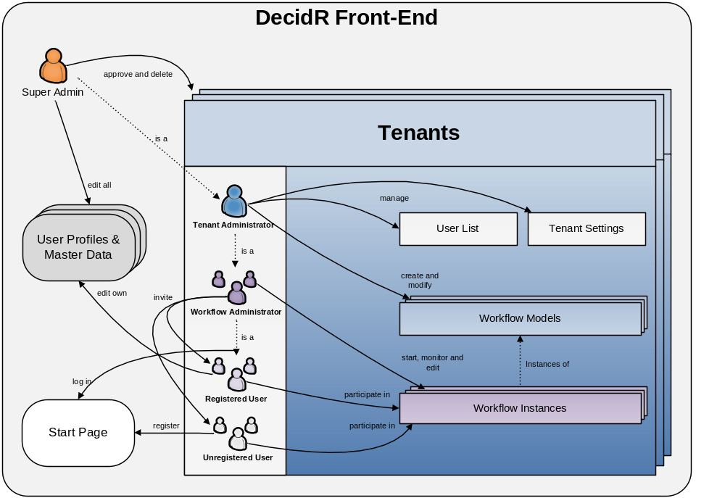

Figure 1: simplified conceptual view of the DecidR front-end
Since DecidR is a web application, users do not need a special client besides an up-to-date web browser to access its features. They must, however, register themselves on the DecidR web site in order to gain the full functionality. The following section summarizes the major functions that DecidR must let the user perform. Details are provided in section [Actors].

System management
  - Approve or decline new tenants.
  - Delete existing tenants.
  - Edit user profiles & master data.
  - Edit system settings.

Tenant administration
  - Create, modify and delete workflow models.
  - Share workflow models with other tenants by making them public.
  - Modify the tenant web page style such as a custom tenant logo.
  - Browse and manage a list of tenant members.

Workflow administration
  - Send participation invitations to registered and unregistered users.
  - Start instances of the workflow models.
  - Monitor the status of running workflow instances.
  - Terminate running workflow instances.

Workflow participation
  - Join existing tenants by invitation.
  - View your personal work list.
  - Complete tasks on your work list such as filling out a web form, uploading files, etc.

Public start page
  - Log in with an existing user account.
  - Create a new user account with or without an invitation. Optionally create a new tenant or join an existing one when creating a new account.
  - Receive a new password if the old one is forgotten.

Personal start page
  - Edit your personal profile including address data, password, membership status etc.
  - Switch between different tenants.

User Classes and Characteristics
The project team anticipates very diverse user groups in terms of frequency of use, technical expertise, experience and educational level. Therefore, the user classes have been distinguished by the subset of used product functions. Note that the user classes are not disjoint. For example, a tenant administrator may himself take the role of workflow admin and workflow participant. There is some correlation with the use case actors found in section 6.1.

Super Administrator
  - Responsible for approving new tenants, manages the database and is capable of repairing the system if an error occurs in one of its components.
  - Familiar with the system and its implementation.
  - Owns all rights and privileges.
  - He is the sole administrator of the default tenant.

Typical example: an IAAS staff member who is involved in the project.

Tenant Administrator
  - Responsible for modeling workflows and managing tenant settings.
  - Has a basic understanding of workflow management, but not necessarily BPEL.
  - Owns all rights within the tenant he administrates.
  - Like any other user, he may participate in workflows.
  - Must be registered on DecidR web site.

Typical examples: managers, teachers, project leaders.

Workflow Administrator
Workflow administrators are very similar to tenant administrators, except for their rights and responsibilities, which are limited to starting and managing workflow instances.

Workflow Participant
  - Only deals with workflows by completing tasks on his personal work list(s).
  - Doesn’t necessarily have any knowledge concerning workflow management.
  - Doesn’t have any special rights or privileges that exceed participation in selected workflows and management of his personal user profile.
  - May not even have registered on the DecidR web site.
  - Uses his web browser and e-mail program competently, but doesn’t necessarily have any other technical or even computer science skills.

Typical examples: students, company employees.

Operating Environment
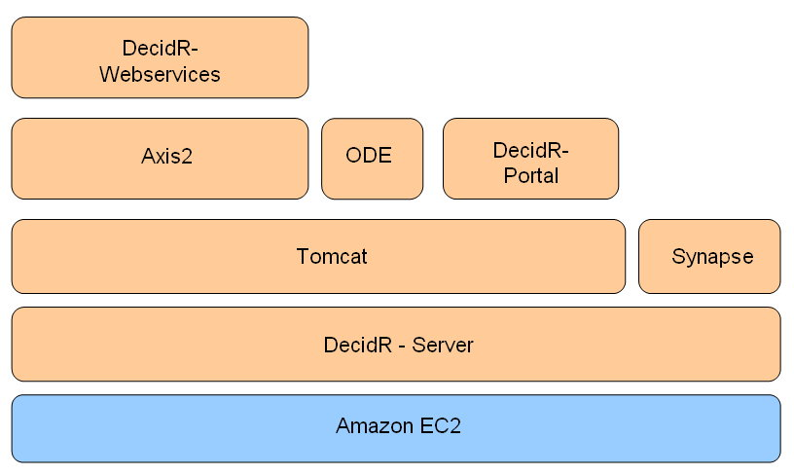

Figure 2: layers of software and infrastructure
DecidR runs on the Amazon EC2, which means it is possible to adjust the computing power within minutes. In addition, DecidR must be designed to run on every system on which Synapse and Tomcat can be deployed, such as ordinary MS-Windows 2003 servers. The DecidR system consists of the DecidR portal and the DecidR Web services. Both components are deployed on the Tomcat server. Furthermore Apache Axis2 and Apache ODE are required to execute the workflow models. Synapse is used for Web service discovery.
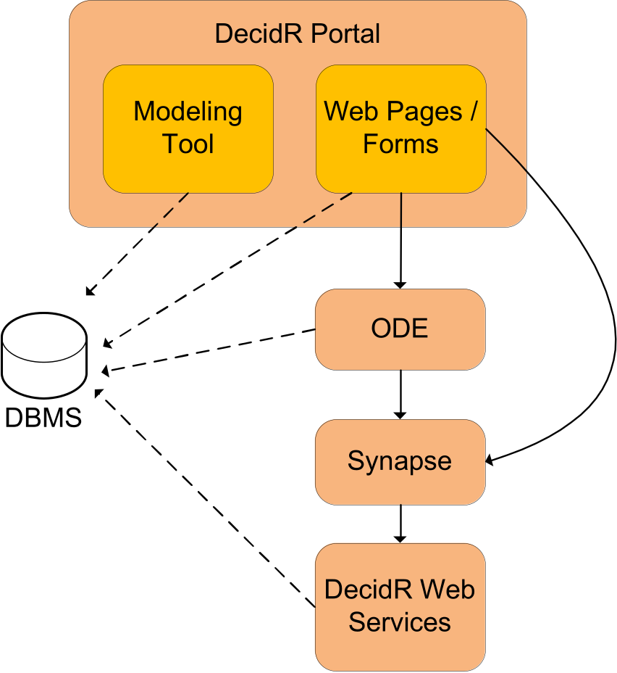

Figure 3: communication between system components
The DecidR portal component provides access to the DecidR system. It is the entry point for anyone who wishes to model and execute decision processes with DecidR. The portal is based on JavaServer Pages and includes the modeling tool and web forms. The modeling tool allows creating and modifying workflow models. The web pages include the function to create instances of the workflow models and to execute them. The workflows are executed by the Apache ODE BPEL engine. The several tasks in the workflow are implemented using Web services. These Web services are accessed through the Synapse ESB. Furthermore the servlets and JavaServer Pages use the database for persistent data storage.

Design and Implementation Constraints
This section describes the issues that will limit the options available to the developers during the design and implementation phases.

User screen resolutions
The user interface must be designed to fit well into a browser window on a screen that has a width of 1024 pixels and a height of 768 pixels. The user interface should scale accordingly if the user is using higher screen resolutions.

Supported browsers
The web front-end must work with Firefox version 3.0 or greater and Internet Explorer version 7.0 or greater.

Third Party Components & Libraries
All used third party components and libraries must be available under a license that is compatible with [licns].

Interfaces to other applications
Users should be able to invoke external Web services in workflows by supplying a WSDL 1.1 file during the modeling stage. However, this is a low priority requirement. There are no interfaces to non-Web service based applications.

Technologies & Standards
All DecidR subsystems except for the front-end (including the modeling tool) must be designed and implemented using Web services. As WS-BPEL only supports WSDL 1.1 [wsdl], the DecidR Web services must be described using the 1.1 revision of the standard.
The workflow instances which are executed on the ODE engine must be described using the WS-BPEL 2.0 standard [bpel].
The front-end must be implemented using JavaServer Pages (JSP) and servlets [srvlt]. It will run in a Tomcat 5.5.x servlet container, which limits JSP to version 2.0 and servlets to version 2.4.

Frameworks & APIs

Java Persistence API (JPA)
The DecidR data model consists of an XML-based model and a relational model. The relational model is represented in Java using the Java Persistence API (JPA). The JPA does not constrain the database design since it allows creating Java data models from existing database schemas.

Infrastructure
DecidR must be deployable in the Amazon EC2 as well as in traditional Linux or MS-Windows server environments. Therefore, the DecidR application must not rely on features, services or technologies that are exclusive to the Amazon EC2, such as the S3 storage service.
An important limitation comes from using MySQL as the persistent data backend: at the moment, the only database engine that supports transactions as well as foreign key consistency is InnoDB. However, creating full text indices is not supported by InnoDB, which must be considered during the design phase.

Tools
The client has not requested the use of specific software development tools.

Language Requirements
All documentation including source code comments must be written in English. Web services must be implemented using the Java language. The project team is free to use the latest Java runtime environment that is supported under the MS-Windows and Linux platforms.

Programming Standards
All code written by the DecidR project team should conform to the Java code conventions [codcv].

User Documentation

Installation Guide
The installation guide contains the necessary steps and prerequisites to deploy the DecidR application on the Amazon EC2 as well as traditional Linux and MS-Windows server environments. Additionally, it explains the configuration files and deployment descriptors that come with the DecidR server components.

Integrated Help
While it’s a very important goal to make the DecidR front-end user-friendly and intuitive, it must provide an integrated help system consisting of hierarchically structured HTML pages. There will be no separate user manual.

Extension Guide
The extension guide should help maintainers of the DecidR application with creating additional modules or services, extending the web front-end, etc.
The guide should contain several use cases that cover the most important extension tasks.

Assumptions and Dependencies
  - The project team assumes (but does not know for a fact) that the requirements concerning the workflow modeling tool can be met using the Draw2D framework. The options provided by the Draw2D framework also determine the degree to which the look and feel of the workflow modeling tool may be customized.
  - There is some dependency on third party software such as Tomcat, Synapse, Axis2, ODE, MySQL (and the InnoDB engine).
  - The project team assumes that a correct mapping between relational database types and Java types is provided by the JPA.

User Interface

Overview
This section gives a brief overview of the DecidR user interface. The user interface will be explained in detail in the external document [uidoc]. The information in this section and the external document can deviate from each other. Due to the fact that this section should give just a first impression, it will not be updated and the information in the external document is valid in case of deviation.

The User Interface allows the user to interact with the DecidR System. It must be designed according to the requirements found in chapter 3.5.1 [User screen resolutions] and chapter 3.5.2 [Supported browsers].

Public Welcome Page
On the public welcome page the user has the opportunity to view information about DecidR, help pages, terms of service and Impressum. Furthermore he is able to login, register and request a new password for his user account if he has forgotten his old password.
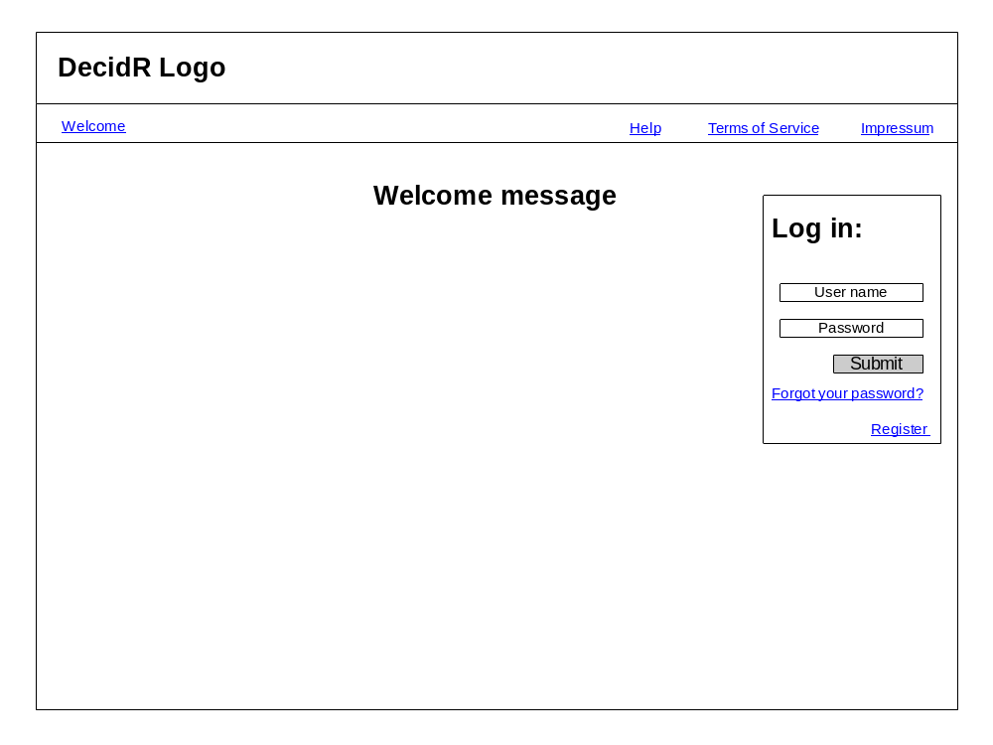

Figure 4: public welcome page

Logged in View
The following picture shows the general layout of the interface for logged in users:
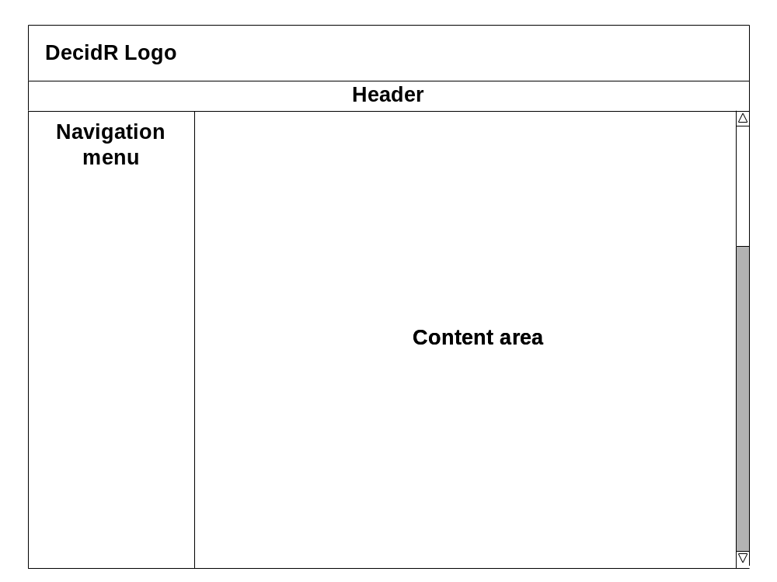

Figure 5: general layout for logged in users
In the logged in status the user has furthermore the opportunity to view help pages, terms of service and Impressum. He also is able to logout.

On the left side, you can see the navigation bar. It has to be adjusted for each user role. Due to the fact that the “higher” users have also the rights of the lower ones, the items of a lower user are also shown for the higher one. A full navigation bar has the following entries:
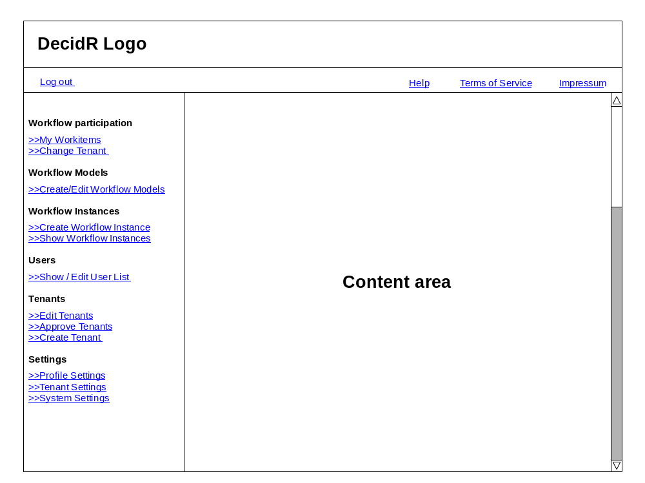

Figure 6: complete navigation menu
The entries for the different user roles are:

User:
  - Work items
  - Profile Settings
  - Change Tenant

Workflow-Admin:
  - Create Workflow Instance
  - Show Workflow Instances
  - Show User list

Tenant Admin:
  - Create/Edit Workflow Models
  - Tenant Settings
  - Edit User list

Super-Admin:
  - Edit Tenants
  - Approve Tenants
  - System Settings

User Pages

Work items
In the navigation bar, the number of new work items will be shown in brackets next to the entry “My Work items”. The work item page shows a table containing all user specific work items of the current tenant. Furthermore the user is able to work on a work item or to mark a work item as done. By hovering over the name of a work item its description can be viewed.
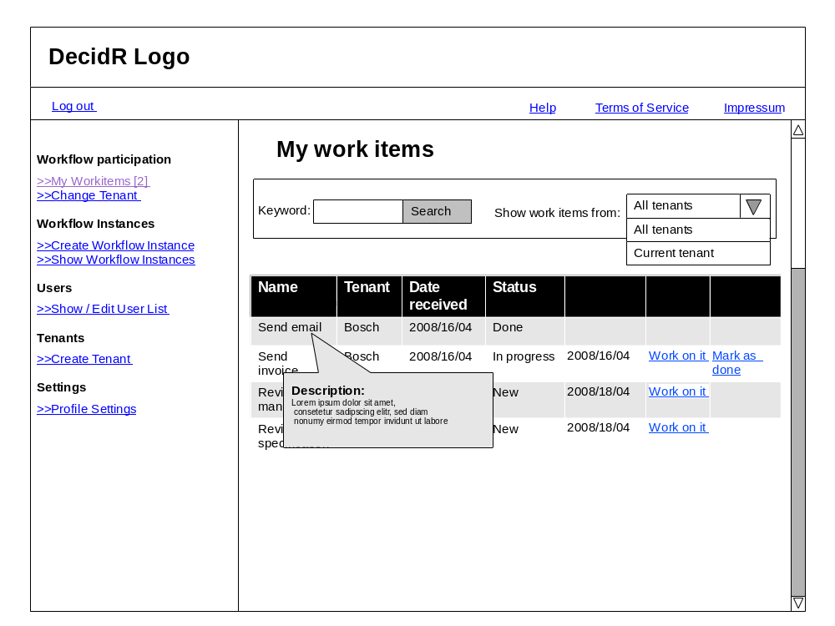

Figure 7: my work items
The user may sort or filter list views. In this case, the user can choose between displaying work items coming from all tenants or just those coming from the current tenant.

Profile Settings
In this section the user can change his profile settings and set his status to unavailable.
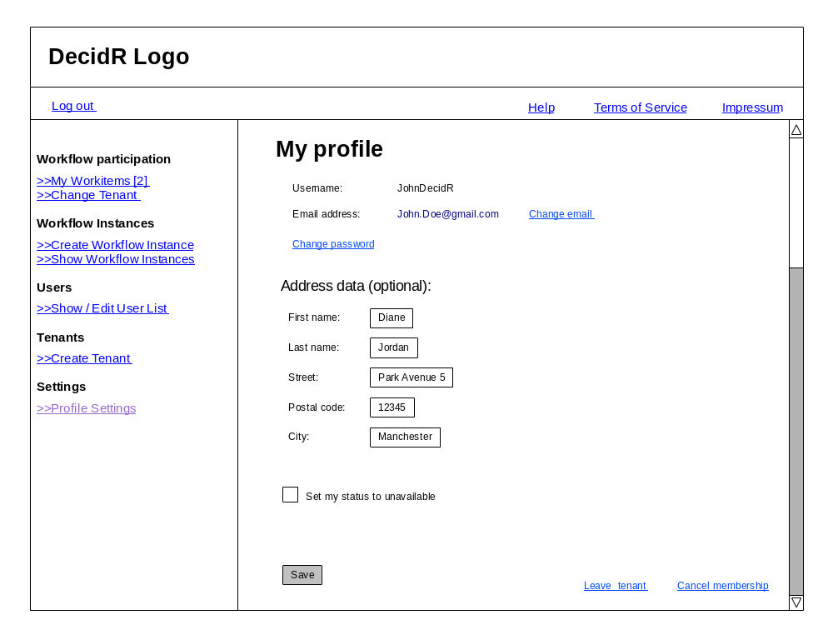

Figure 8: profile page

Change Tenant
In this section the user can switch between tenants. A list of all tenants the user is member of is shown. By clicking on a switch button next to a tenant name he can change to this tenant. In addition, the tenants that still need to be approved by the super admin are listed here.
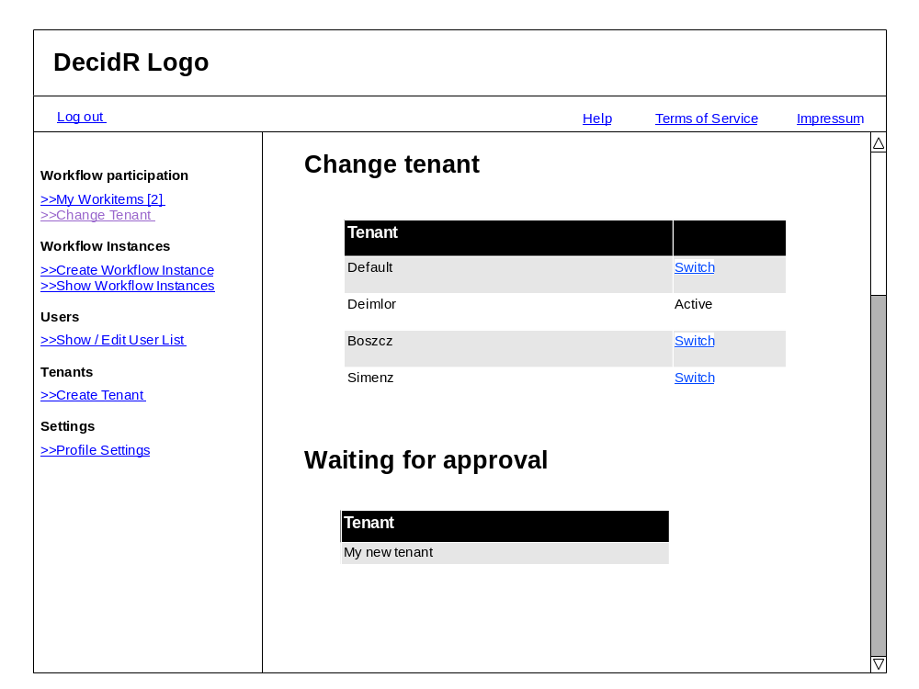

Figure 9: change tenant page

Workflow Admin Pages

Create Instance
On this page all workflow Models the workflow admin has access to are shown. He is able to create an instance of one of the models by clicking on the “create instance” button next to the model name. He is also able to filter the workflow models.
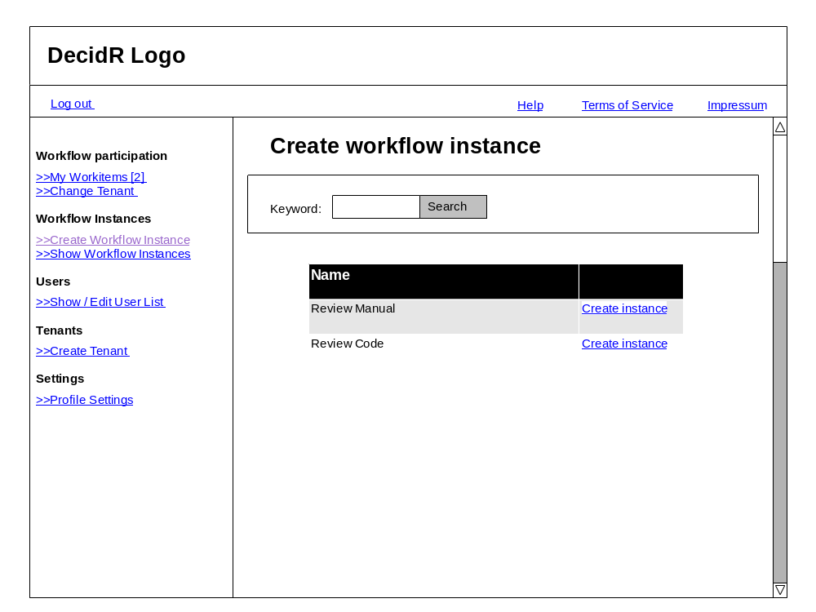

Figure 10: create workflow instance
After clicking on a “create instance” button, the user have to set the model specific variables and to assign users to the instance.

Show Workflow Instances
In this section the user can see all running instances of the current tenant and if required he can stop them.
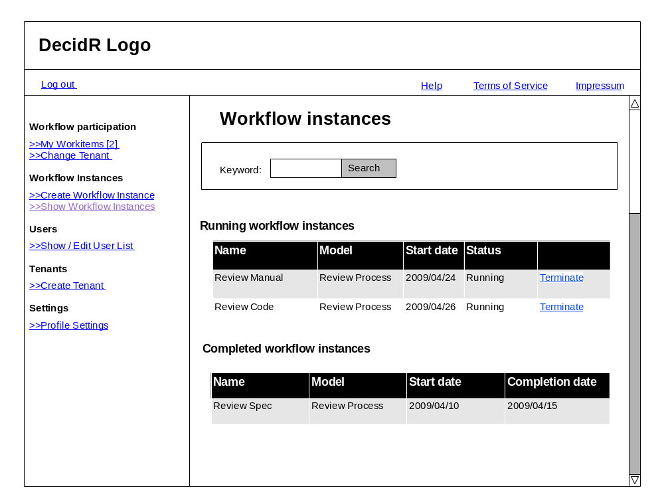

Figure 11: show workflow instances

Show User List
By using this item the workflow admin can view all users, which are a member of the tenant.
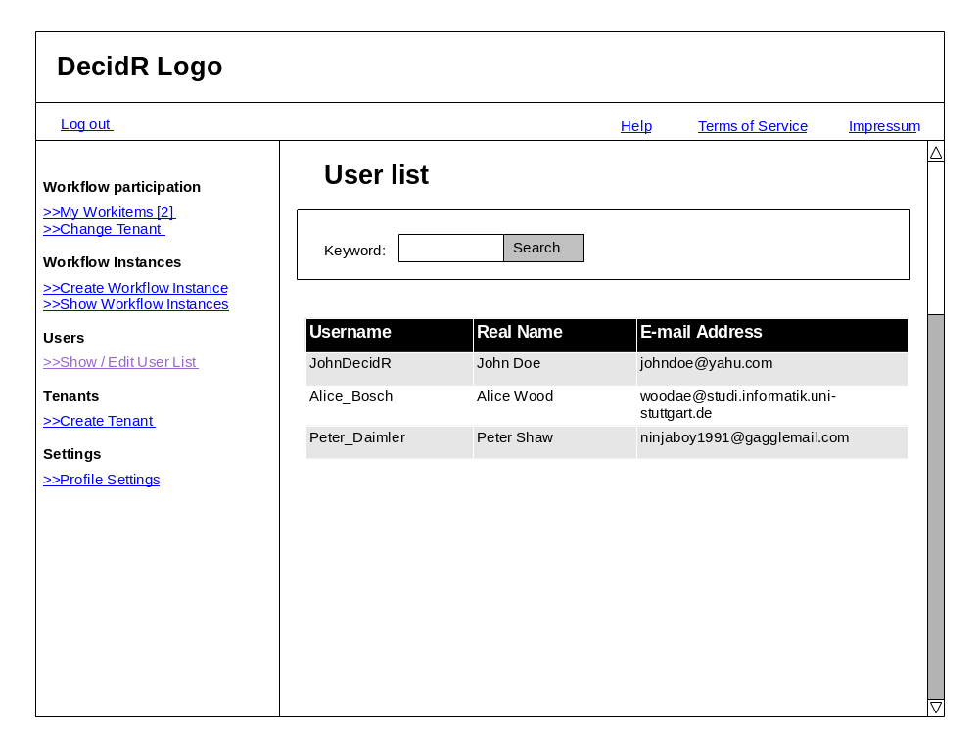

Figure 12: show user list

Tenant Admin Pages

Create / Edit Workflow Models
Here the User can see a list of all public and tenant specific workflow models. The user is able to create a new workflow models and to edit, delete, publish or un-publish and to appoint the workflow administrators to tenant specific models.
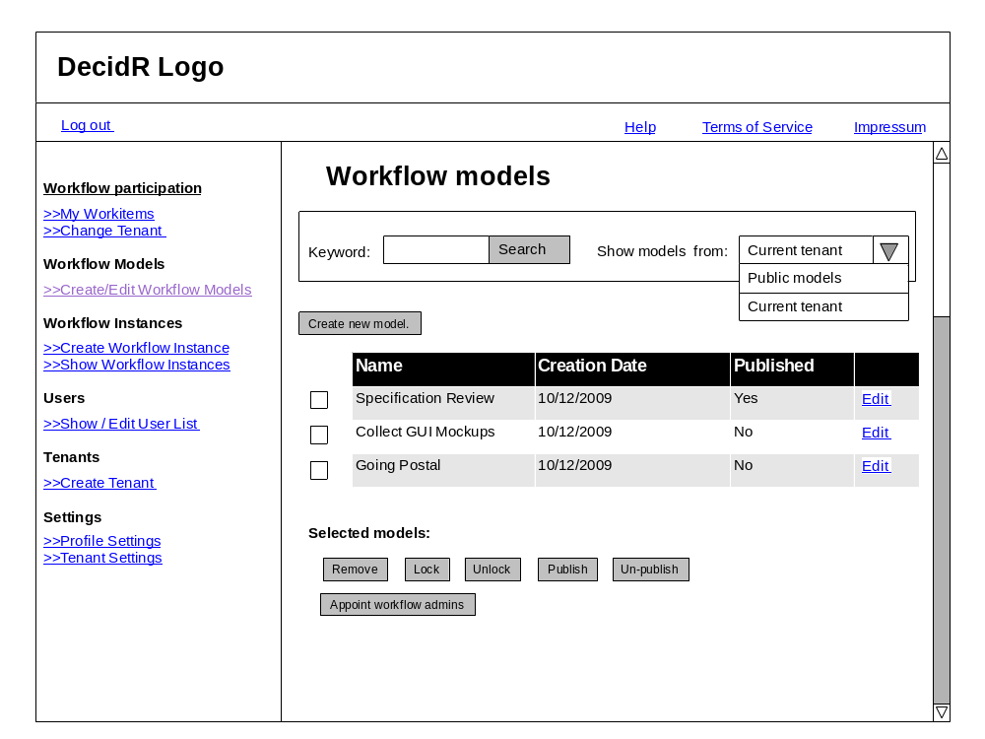

Figure 13: workflow model view (current tenant)
By pressing edit button in the “current tenant view”, the user is able to edit the model and its name.
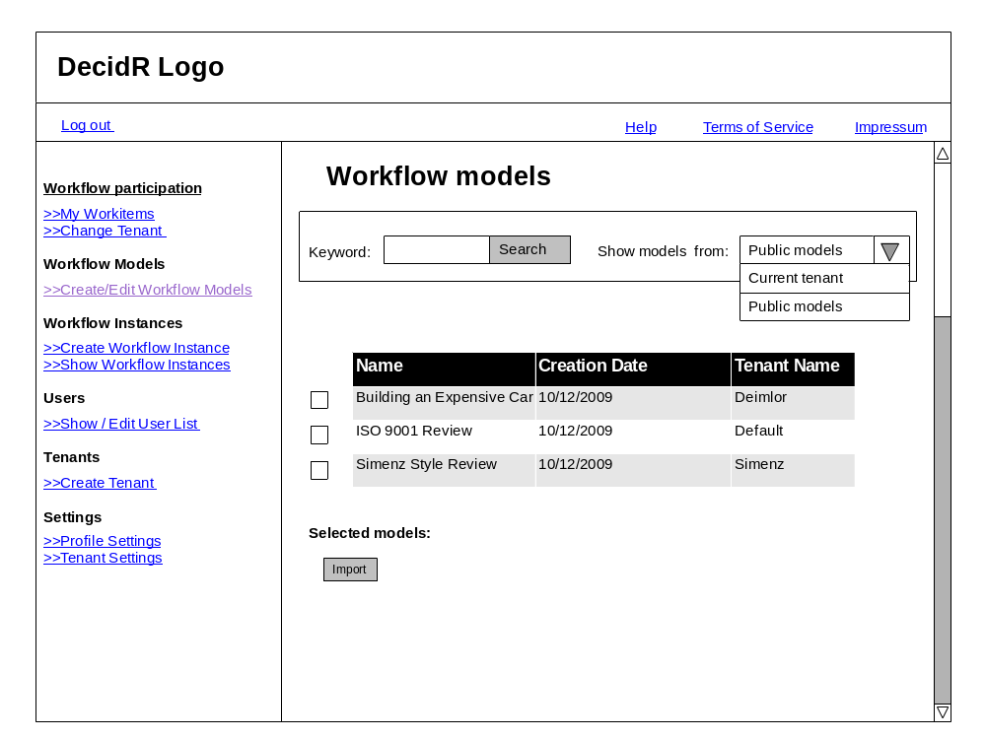

Figure 14: workflow model view (public models)
The tenant admin can change the view to the public mode by using the combo box. In this view he is able to import one or more public models into his tenant.

Tenant settings
On this page the user can change the tenant specific data. He can set an information text, a logo and the tenant specific color scheme. Furthermore he can navigate to the advanced settings.
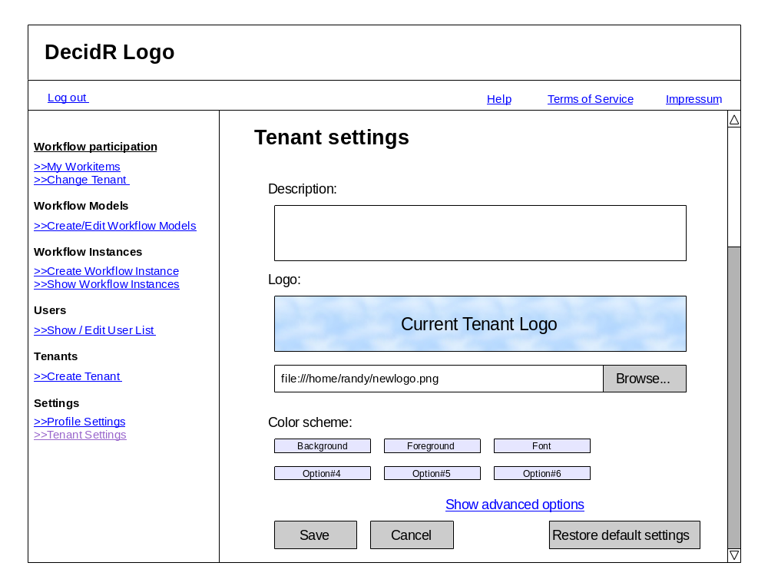

Figure 15: tenant settings (simple)
Using the advanced settings, the tenant admin is able to set the color scheme by supplying a CSS file.
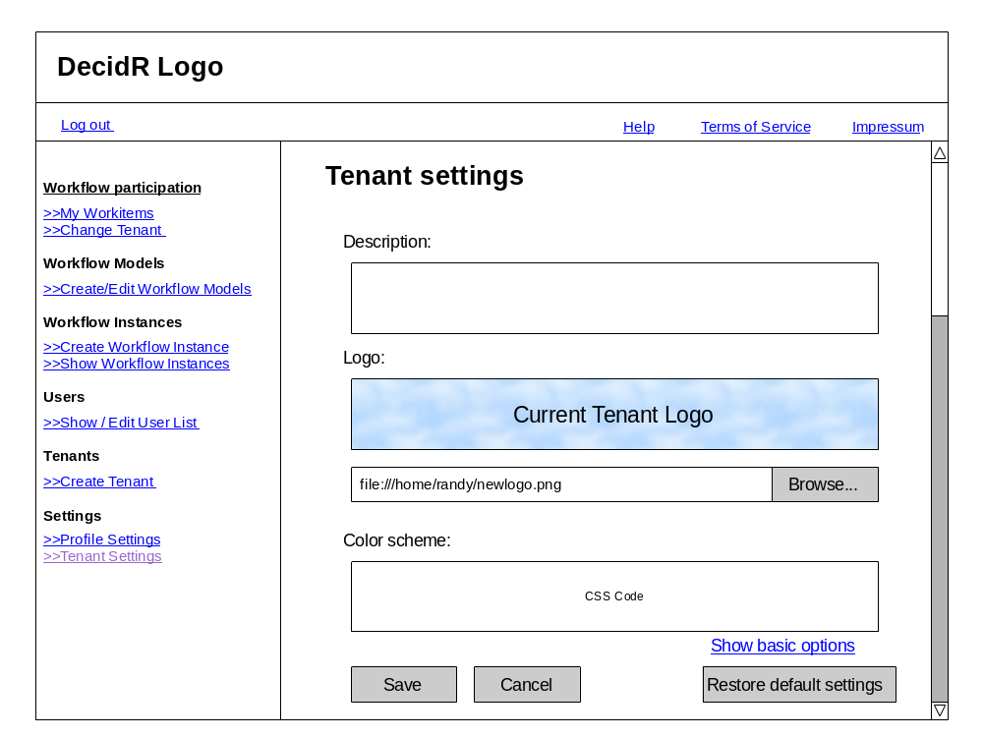

Figure 16: tenant settings (advanced)

Edit User List
On this page, the tenant admin can delete and invite users to the tenant. He can also transfer his tenant admin role to another user. Furthermore he can change the user data. He also can filter the shown information.
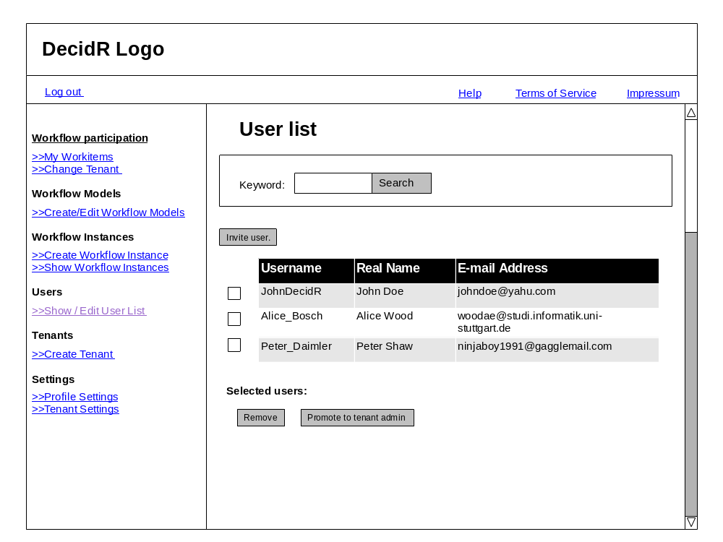

Figure 17: edit user list (tenant admin)

Super Admin Pages

Edit Tenants
On this page the super admin can list all tenants and delete them.
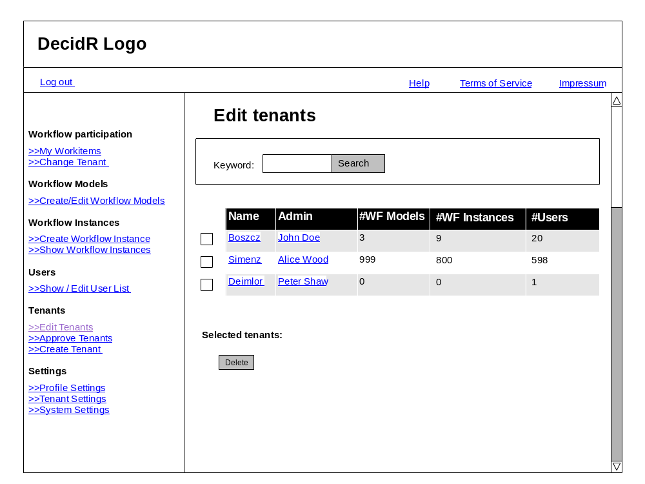

Figure 18: edit tenants

Approve Tenants
In this section the super admin can approve or decline tenant registrations.
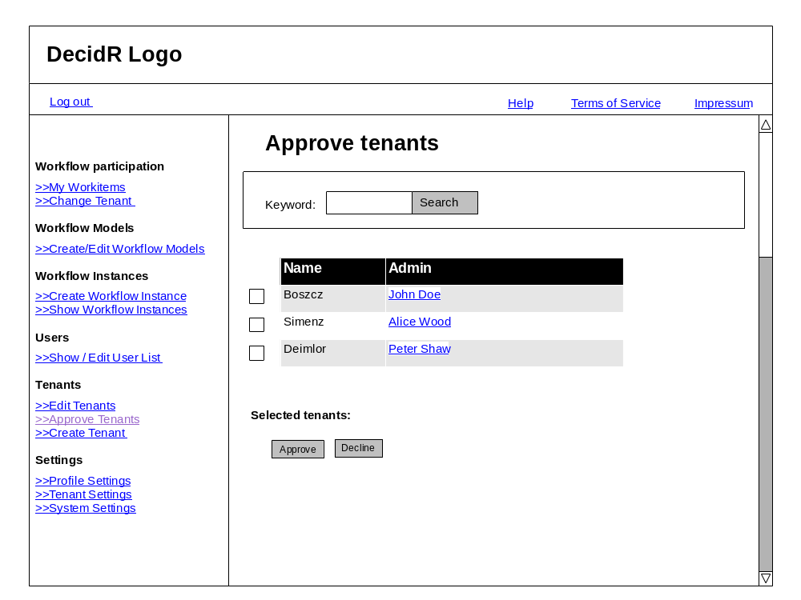

Figure 19: tenant approval

System Settings
In this section the super admin can change the log level and can choose whether tenants registrations should approved automatically or not.
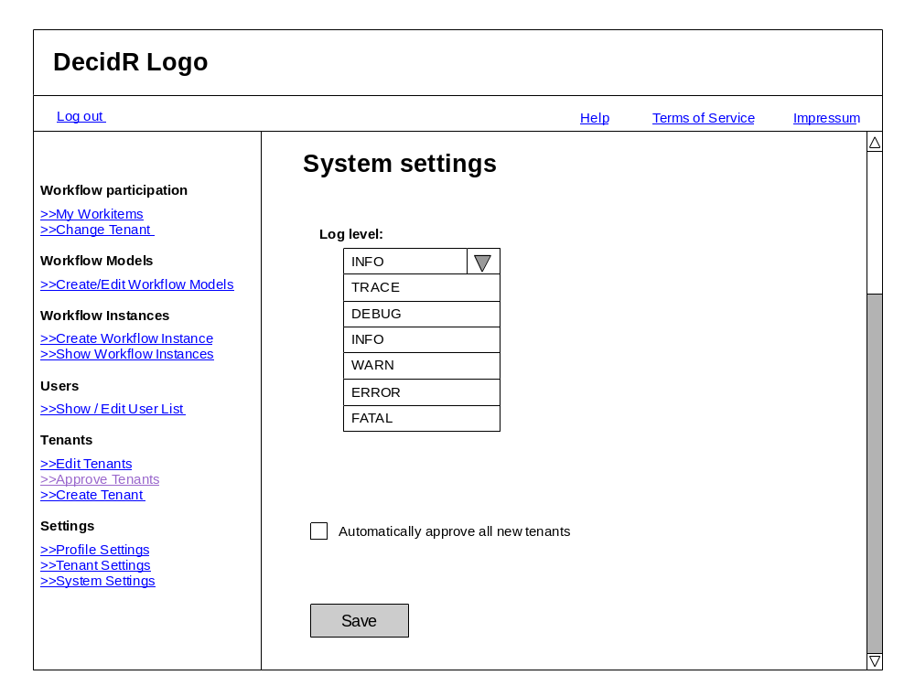

Figure 20: system settings

Show /Edit Users
On this page the super admin can show all users. He may edit any user profile, remove users from the current tenant, and disable or enable user accounts.
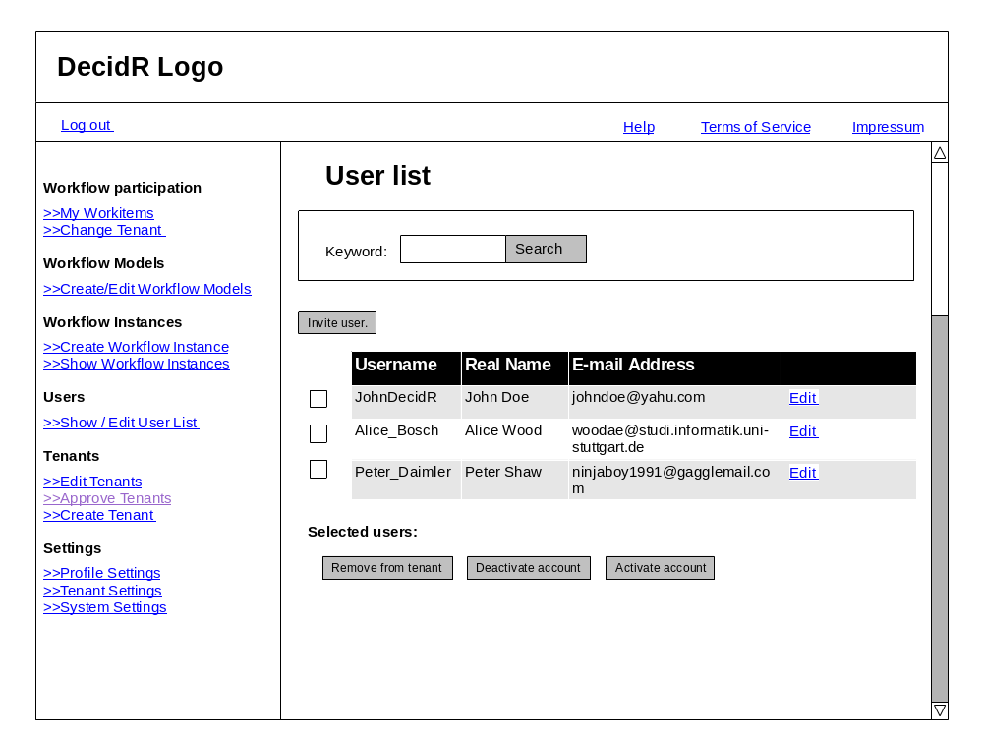

Figure 21: edit users (super admin)

Modeling Tool and Modeling Semantics
The purpose of this chapter is to describe the Modeling Tool of DecidR and the underlying semantics. The user can model workflows graphically with the Modeling Tool. The BPEL semantics of the graphical elements are described in this chapter.

Overview
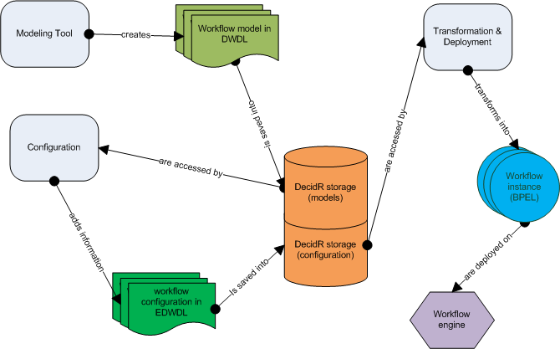
Figure 22: conceptual interaction between the workflow modeling and instancing components
The tenant admin models a workflow with the modeling tool. The workflow is saved in an XML file. The XML Format of the file is the DecidR Workflow Definition Language (DWDL). The XML file serves two purposes: It is the source document for the transformation into a BPEL workflow and is the storage format for the graphical representation of the workflow. The tenant admin can create and edit workflow models. Workflow models are saved as XML files in the DWDL format. A transformation and deployment component is responsible for the conversion from DWDL to BPEL and for the deployment on to a workflow engine. The workflow admin can and in some cases has to configure the workflow model by adding additional information in order to execute the workflow. The workflow admin can save and edit workflow configurations without starting a workflow instance. Workflow configurations are saved as XML files in the extended DWDL (EDWDL) format. Whenever the workflow admin wants to start a workflow, meaning creating an instance of the workflow, the transformation and deployment component is activated.

The Modeling Tool
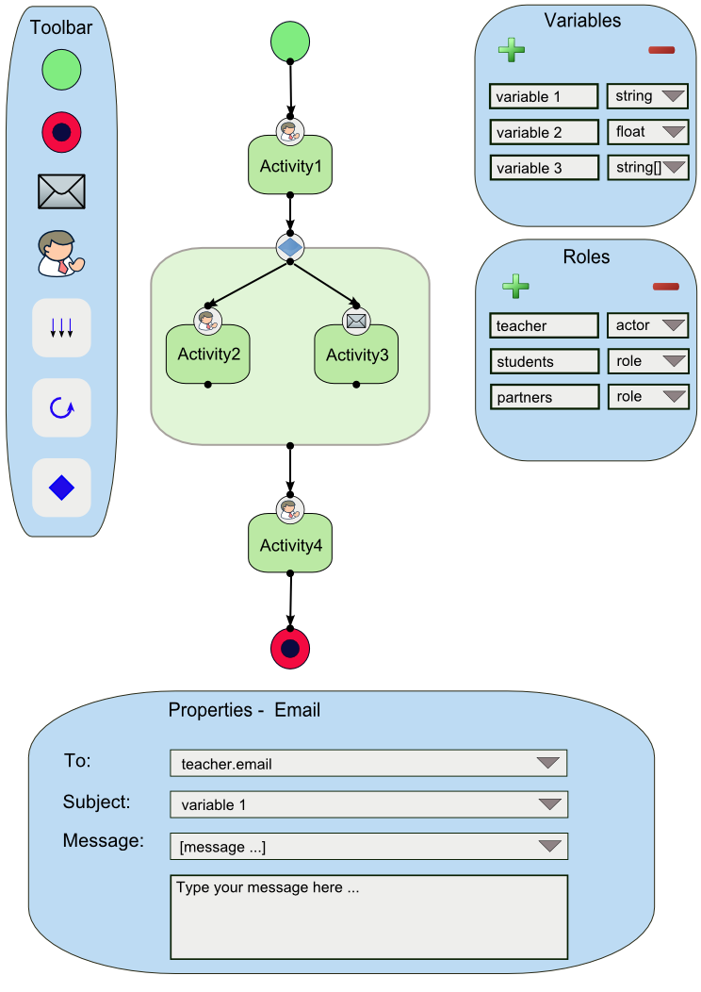

Figure 23: view of the modeling tool
The modeling tool allows the tenant admin to design a workflow. Workflows are basically designed as a graph with nodes and edges. A node represents an activity or a container. Edges represent the control flow. The modeling tool interface consists of a canvas, a toolbar, a variables list, a role list and a property window. The graphical elements of the workflow are placed on the canvas. The toolbar allows the tenant admin to choose from activities and containers and place them on the canvas. In the variables list, the tenant admin can add, modify or delete variables which serve either as input or as output variables for the activities. With the role list the tenant admin can define roles. The property window displays the preferences of each activity, for example input and output variables.

Toolbar Elements
- Workflow related elements
  - E-mail Web service activity
  - Human Task Web service activity
  - Flow container
  - If container
  - For Each container
- Editor related elements
  - Undo: The user can undo his last action
  - Redo: The user can redo a revoked action
  - Clear: Clear the workflow canvas to the default
  - Delete: Deletes a workflow element
  - Save: Saves the workflow

Variables List
The Variables List contains a list of variables. The tenant admin can add, modify or delete a variable from the list. Each entry of the list contains the unique variable name, the variable type and the variable value. Every variable is globally available, that means every variable on that list can be assigned to every activity as either an input variable or an output variable. The assignment is done in the property window of each activity. A variable can have one of the following types:

- Simple types
  - Integer
  - Float
  - String
  - Boolean
  - Date (consisting of year, month and day)
- Complex types
  - File reference: a file reference is an URL which points to file that is stored in the internal DecidR data storage service.
  - List of any simple type or file reference.

Role list
The role list contains a list of roles. The tenant admin can add, modify or delete an entry from the list. Each entry of the list contains the unique role name and the role. There can be two types, either a role (a set of persons) or an actor (exactly one person). Example: In a university lecture context, a role would be “student” (a set of persons); an actor would be “professor” (exactly one person). The “For Each container” can iterate over a role, but not over an actor. The “Human Task activity” accepts as input variable user an actor, but not a role.

Property Window
Whenever a tenant admin clicks on an activity or container, a property window is displayed. Only one property window can be displayed at any time. In this property window he can configure the activity or container. For every input and output variable of an activity, the tenant admin can assign a variable from the variables list through a pull down menu. Alternatively, instead of assigning a variable, he can choose to enter the value of the input or output variable of an activity directly by choosing a special entry of the pull down menu. A text field or area is displayed, where he can enter the value of the input variables. An example can be seen in figure 23 where the e-mail message can be entered directly in the text field below.

Activities
The following section describes the activities of which the workflows are composed. Each activity has a short description of its functionality. The “Properties” section specifies the contents of the property window of an activity. Whenever a new workflow model is created, the workflow model contains exactly one start activity and exactly one end activity by default. The start and end activity cannot be removed from the workflow.

Start activity
Every workflow has to start with a start activity. It represents the beginning of the control flow. Within a start activity, a tenant admin can determine the configuration variables of the workflow. The configuration variables are normal variables which are created through the variables list and are assigned as configuration variables in the property window of the start activity. All configuration variables together constitute the start configuration of the workflow. The start configuration has to be initialized by the workflow admin. The concept of configuration variables allows the tenant admin to model workflows independently of a workflow admin specific scenario. Having to initialize the start configuration, the workflow admin is able to customize each workflow instance to his wishes.

End activity
Every workflow has to end with exactly one end activity. If the control flow of a workflow instance reaches this activity, the workflow instance counts as successfully executed.

Properties:
- Fault handler: the tenant admin has to define a role or an actor to which an e-mail (with a customizable message) will be sent if the execution of a workflow instance has failed for any reason.
- Notify of Success: the tenant admin can check whether an e-mail should to send out to a role or actor if the control flow has successfully reached the end activity.

E-mail Web service activity
The E-mail Web service sends e-mails to a given address with a specific subject and message.

Properties:

- Input variables
  - To (string, actor or role): has to contain the recipient’s E-mail address
  - CC (string, actor or role): can contain the recipient of a carbon copy
  - BCC (string, actor or role): can contain the recipient of a blind carbon copy
  - Subject (string): has to contain the subject of the e-mail
  - Message (string): can contain the message body of the e-mail
  - Attachment (list of file references): can contain a file reference to the file that will be sent out as an attachment to the e-mail. In the workflow model, only a file reference is given, the actual file will be attached by the e-mail Web service.
- Output variables
  - Sent (Boolean): Whether the e-mail was sent successfully or not

Human Task Web service activity
The Human Task Web service creates work items for a specific participant of a workflow instance. The work item is displayed in the user’s work item list. A work item consist basically of a text part, an input form part and optionally a file upload and provide part. The text part describes what the user’s task is and what he has to do. The input form part contains one or more input fields, where the user can enter his result of the task he has been given.

Properties:

- Input variables
  - User (actor): Has to contain the username of the user who the task is designed for
  - Task description (list of strings): Has to contain the description of the task
  - File (list of file references): Can contain a file reference to a file
- Output variables
  - Input field (list of string, date, integer, Boolean or float): Can contain the values of the input fields from the input form part
  - File (list of file references): Can contain the file reference to a file the user has uploaded
- Options
  - Notify user per e-mail: The tenant admin can decide whether an e-mail should be sent out notifying the user that a new work item was assigned to him
- Form elements
  - All form elements such as labels, input boxes and static texts (see below).

Form designer
The input form part of the human task activity appears basically as form in the work item for the user once the workflow has been executed. Within this form, the user can enter text fields and upload files. In order to create such a form, the tenant admin must use the form designer which is displayed within the property window of the human task activity. With the form designer, the tenant admin can determine the label, type, amount and order of the input fields. The following set of types is available:
- Integer
- Float
- Boolean
- String
- Date
- File Upload
The first five types result in a corresponding input field. If the type file upload is selected, a file upload dialog will be part of the form.
Every input field defined with the form designer will become an output variable of the human task activity.
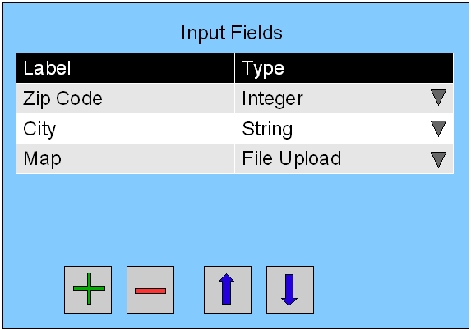

Figure 24: form designer

Containers

Flow container
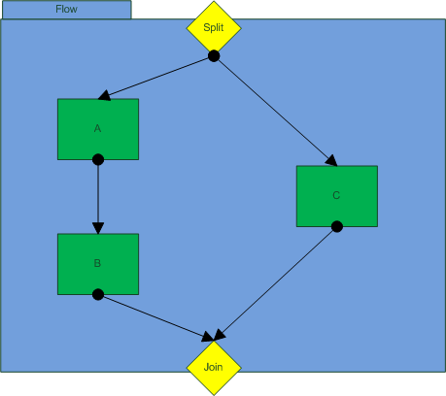

Figure 25: flow container
If the tenant admin wants two or more activities or sequences of activities to be executed simultaneously, he has to place them in a flow container. A flow container consists of a split point, a join point and the container area. The split point is the target for an incoming edge outside the flow container. The split point is also the source of outgoing edges inside the container which point to activities that are executed simultaneously. The join point is the target for incoming edges from inside the flow container, that means every activity or sequence activity inside the flow container ends at the join point. The join point is the source of the outgoing edge outside the flow container. The join point is a gateway with an AND-condition. Every activity or sequence of activity has to end successfully to continue the control flow after the flow container.

If container
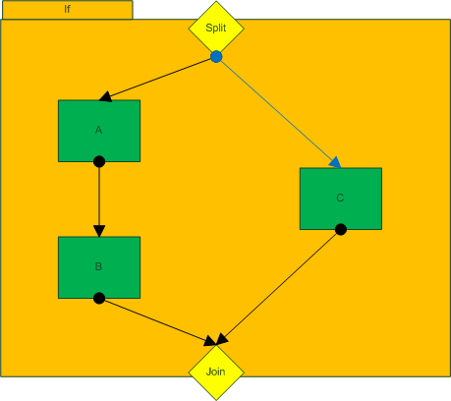

Figure 26: if container
If the tenant admin has two or more activities or sequences of activities and he wants only one of them to be executed depending on whether certain conditions are true or not, he has to place them in an if container. An if container consists of a split point, a join point and the container area. The split point is the target for an incoming edge outside the if container. The split point is also the source of outgoing edges inside the container which point to activities. In order to secure the execution of at least one sequence of activities even if no condition statement is true, there is one special outgoing edge from the split point: it has a different color and points to that sequence of activities which is executed if no condition is true. The join point is the target for incoming edges from inside the if container, that means every activity or sequence activity inside the if container ends at the join point. The join point is the source of the outgoing edge outside the if container. The join point is a gateway with an XOR-condition. Only one activity or sequence of activity has to end successfully to continue the control flow after the if container.

Properties:
For each outgoing edge, the tenant admin must define a transition condition. A condition statement is a Boolean expression where relational operators are applied to variables or roles. A condition statement looks like the following:
<variable, list or role> <relational operator> <value, variable, list or role >

The variable, list or role can be selected by a pull down menu. According to the type of variable or list, the set of allowed relational operators are presented in an additional pull down menu. The value to which the variable is compared to has to be entered in a text field. The following relational operators are allowed for each type of variable:
- String
  - Equal to (“==”)
  - Contains (“?=”)
  - Not equal to (“!=”)
- Integer and Float
  - Equal to (“==”)
  - Not equal to (“!=”)
  - Smaller than (“<”)
  - Smaller than or equal to (“<=”)
  - Greater than (“>”)
  - Greater than or equal to (“>=”)
- Date
  - Equal to (“==”)
  - Not equal to (“!=”)
  - Before (“<”)
  - After (“>”)
- Boolean
  - Equal (“==”)
  - Not equal to (“!=”)
- Role/List
  - The same relational operators as listed under “integer and float” can be applied. But here, the comparison is in regard to the cardinality of the list or set respectively.

For each container
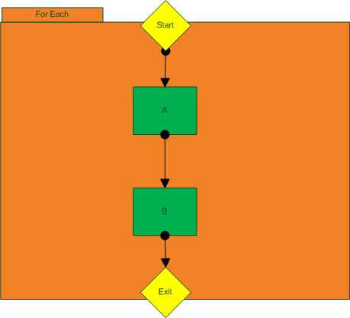

Figure 27: for each container
The for each container allows a tenant admin to iterate over a range of integer values, lists or roles. The activity or sequence of activities in the container is executed every iteration. Within a for each container, a loop variable is available. The type of the loop variable corresponds to the iteration object. The loop variable is a local variable, i.e. it can only be chosen by the activities in the container as an input or output variable.

Properties:

- Iteration object: the tenant admin can choose to iterate over a range of integer values, lists or roles
- Execution method: the tenant admin can choose the way in which the activities in the container are executed. The tenant admin can choose between a sequential or parallel execution. In a sequential execution, the activities are executed for exactly one element of the iteration set. After the activities are successfully executed for that element, the activities will be executed for the next element of the iteration set until the activities have been executed for every element of the iteration set. In a parallel execution, the activities are executed for all elements of the iteration set at the same time.
- Exit condition: the tenant admin can choose between an AND- or XOR-Exit. An AND-Exit means that every activity has to end successfully in order for the control flow to continue after the “for each” container. A XOR-Exit means that only one activity has to end successfully. If a sequence of activities has been defined in the container exactly one whole sequence has to complete successfully in order to meet the XOR-condition.

The DecidR Workflow Definition Language (DWDL)
The DecidR Workflow Definition Language (DWDL) is an XML-based language. It has two purposes: The first purpose is to serve as a data format to store the workflow models and configurations, i.e. it contains all semantic and graphical information that is necessary to load a model into the modeling tool. The second purpose is to serve as source format for the transformation into a BPEL workflow. In order to minimize the complexity of a transformation to BPEL, the DWDL was designed with BPEL in mind, i.e. many elements of DWDL are merely a reduction of the according BPEL elements. In this section, the XML schema [dwdl] of the previous activities and container will be discussed.

Introduction to System Features

Actors
The system roles are designed in hierarchical structure. A more privileged user can perform the operations which a less privileged one can perform plus additional ones (for exceptions see Business Rules).

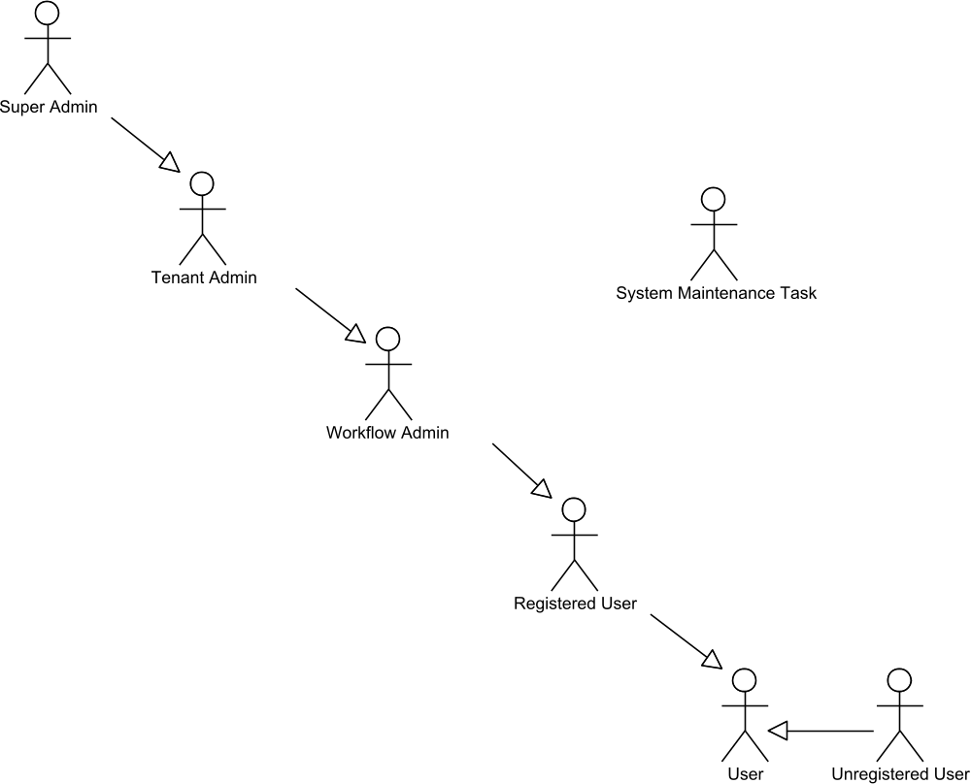

Figure 28: user overview

User
Every person who interacts with the DecidR system is a user. All other actors are specializations of the user.

Unregistered User
The unregistered user does not have a user profile, but his e-mail address may already be known to the system, i.e. he may have an “account”. He is able to see the public information on the public part of the DecidR page. He can also take part in workflows, if he is invited by a workflow admin.

Registered User
A registered user has performed the DecidR registration and has a user profile associated with his account. He is able to take part in workflows, switch between tenants and can change his profile data.

Workflow Admin
The workflow administrator is a registered user who has been given the rights to administrate one or more workflows by the tenant admin. He is able to invite new users to a tenant.

Tenant Admin
The tenant admin is a workflow admin who has the additional rights to create and modify workflow models. He can also change the tenant settings.

Super Admin
The super admin is the head of the DecidR system. He has all rights in all tenants. He can access to all objects. Furthermore he can change the system settings and is the sole administrator of the default tenant.

System
Occasionally certain system components are used as subjects in the use case flow descriptions. This includes the user’s web browser, the workflow model editor and “the system”, which refers to the web front-end most of the time. None of these system components are actors, as they don’t trigger use cases themselves but simply respond to requests made by an actual actor. There is, however, one exception:

System Maintenance Task
The system triggers a maintenance task every 24 hours, which checks whether database objects like invitations are still valid or not. If they aren’t valid the task will delete them.

Error Handling
In the use cases found in the “System Features” section, only errors that do not occur due to the unavailability of a vital system component and / or concurrent access are handled. The system does, of course, handle all predictable errors. However, those which aren’t explicitly mentioned in the use cases will be handled on a global level and the user will receive an error message of the “please try again later” style. In general, all error messages must contain useful information for the user and mustn’t simply state unhelpful error codes.

Client Side Interruptions
There are a few things that can possibly halt the execution of a use case which aren’t explicitly mentioned. A user could, for instance, simply close his web browser when asked to make a certain input, the browser may crash, the internet connection may go down, etc.
Where such client side interruptions have no consequences other than stopping the use case execution, no alternative flows have been modeled.

Sessions
Since HTTP is a stateless protocol, certain information such as the user’s login state is stored by setting up a so-called session. All information that is saved using a session is lost when that session expires, which happens when the user logs out of the system or does not interact with a DecidR web page for a certain amount of time. It follows that the user is automatically logged out of the system if the latter is the case, as described by the “Time Limits” section.

Concurrency
In the following use cases in section system features there is no error handling for concurrent use of data. There will be following problems which could occur:

- A user wants to access to a file which does not longer exist.
System reaction: An error message will be shown.
- Two users change the content of and file and save it “parallel”.
System reaction: There are no parallel save operations. The operations will be
performed in order and the last saved data is valid.
- User A is shown some data which will be changed by another user B. User A performs an operation with the old data.
System reaction: The operation will be performed with the old data.

Access Control
In the following use cases in section system features there will be no information about the access rights to different objects. The user will only be shown the objects he has the right to access for. For security the system will check before accessing an object if the user has the rights to access. This guarantees that no user can access files he shouldn’t access by using other communication ways besides using the DecidR pages.

Priorities
Property | Description
Must-have | Must-have features are essential for the DecidR system. These features will be implemented first and are part of the first iteration. The DecidR team assures that these features are completely implemented by the end of the project.
Desirable | The DecidR team aims to implement these features until the end of the DecidR project, but does not assure that these features will be implemented.
Nice-to-have | The DecidR team will implement these features, if there is enough time left after implementing and testing everything else.

System Features

Info Pages
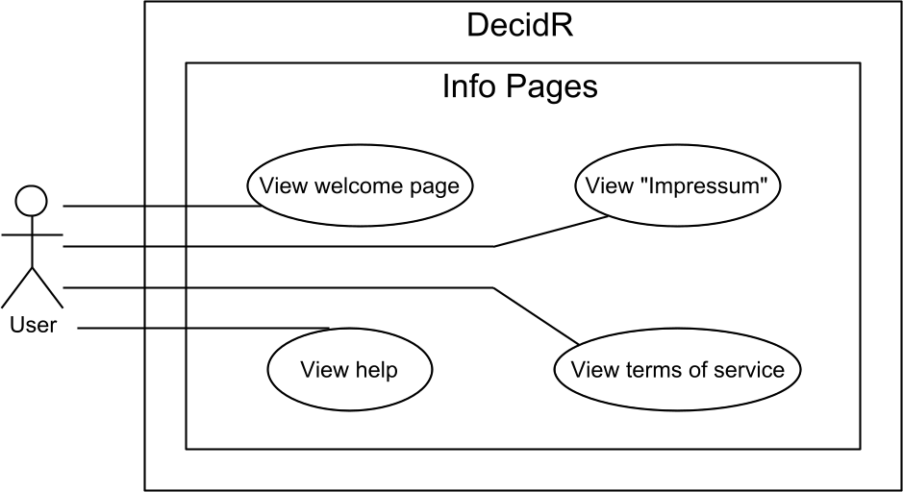

Figure 29: use case overview “info pages”

View “Impressum"
Priority | Must-have
Reference | Figure 4: public welcome page  Figure 6: complete navigation menu
Goal | The user wants to see the Impressum.
Precondition | The user has opened any site of the DecidR web page.
Basic flow | - The user clicks on the „Impressum” link at the header.  - The system shows the Impressum page.
Postcondition | Impressum page is shown.

View terms of service
Priority | Must-have
Reference | Figure 4: public welcome page  Figure 6: complete navigation menu
Goal | The user wants to see the terms of service.
Precondition | The user has opened any site of the DecidR web page.
Basic flow | - The user clicks on the „terms of service” link at the header.  - The system shows the terms of service page.
Postcondition | Terms of service page is shown.

View help
Priority | Must-have
Reference | Figure 4: public welcome page  Figure 6: complete navigation menu
Goal | The user wants to see the help pages.
Precondition | The user has opened any site of the DecidR web page.
Basic flow | - The user clicks on the „ help” link at the header.  - The system shows the help pages.
Postcondition | Help pages is shown.

View welcome page
Priority | Must-have
Reference | Figure 4: public welcome page
Goal | The user wants to see the welcome page.
Precondition | The user has opened the DecidR main page in his web browser.
Basic flow | - The user clicks on the „ welcome” link at the header.  - The system shows the welcome page.
Postcondition | Welcome page is shown.

Account Management
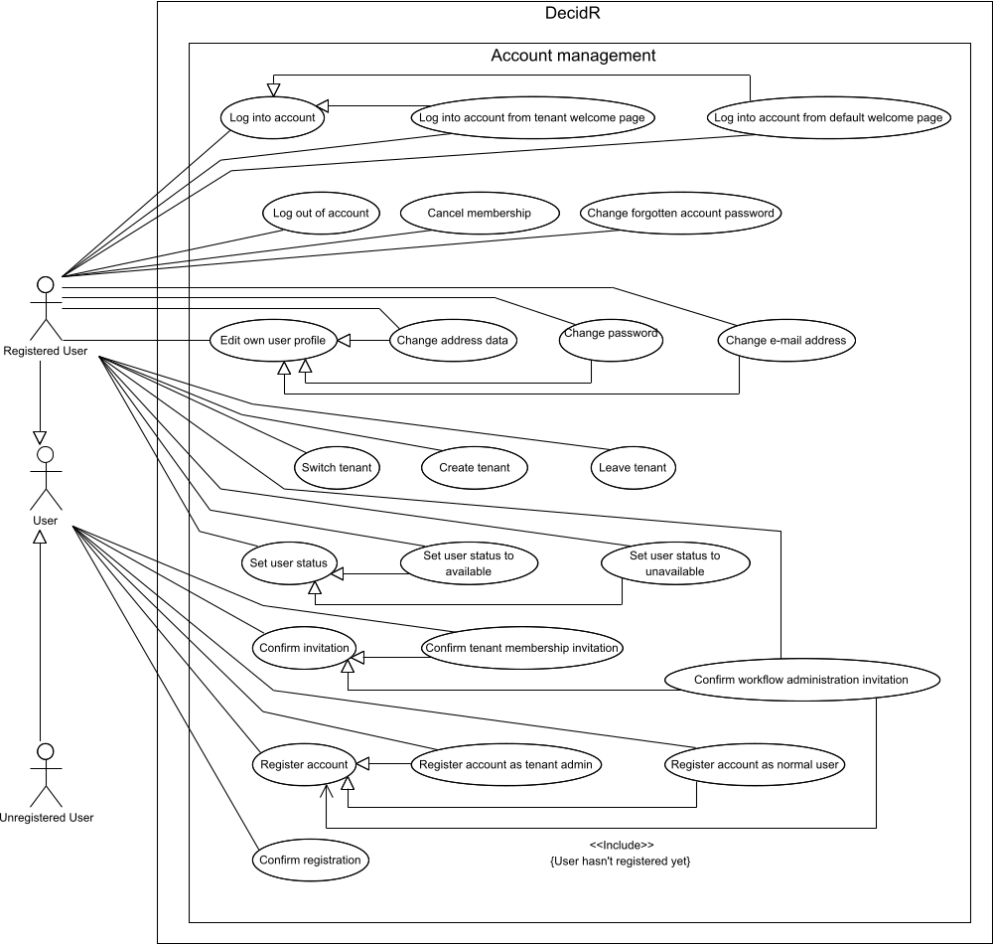

Figure 30: use case overview “account management”

Register account as tenant-admin
Priority | Must-have
Reference | Figure 4: public welcome page
Goal | The user wants to register as a new tenant admin and wants to create the corresponding tenant.
Precondition | The user has opened the DecidR main page in his web browser.  The user is not logged in.
Basic flow | - The user follows the registration link.  - The system displays the registration page in the web browser.  - The user chooses to create a new tenant along with his account.  - The user enters his e-mail address and name, accepts the terms of use and optionally enters additional address data.  - The user enters the tenant data.  - The user presses the “Continue” button.  - The system validates the given profile & tenant data. (see User Input Constraints). The system also checks whether:  - The e-mail address has already taken by another user.  - The user name has already been taken by another user.  - The tenant name has already been taken.  None of the above is the case.  - The system creates the user profile and the new tenant and flags both as unconfirmed. The system makes the user the tenant admin of the new tenant. The system sends a confirmation e-mail to the user’s e-mail address.  - The system checks whether new tenants must be approved by the super admin, which is the case.  - The system displays a web page in the browser which informs the user that he must confirm his e-mail address to complete the registration process (see Confirm registration) and that the new tenant must be approved by the super admin.
Postcondition | The user is not logged in.  The web browser is displaying an info message in the web browser.  The system has created a corresponding user profile, which is flagged as unconfirmed.  The system has sent a confirmation e-mail to the user’s e-mail address. The user may use this e-mail to confirm his registration.  The system has created a new tenant which is flagged as unconfirmed until it is approved by the super admin.
Alternative flow (1) | 6a. At least one profile date is invalid, the user hasn’t accepted the terms of use or username/tenant name/e-mail address has already been taken.  7a. The system displays the appropriate error message(s) in the web browser.  8a. Continue with step 4.
Alternative flow (2) | 9a. The system settings define that new tenants are automatically accepted.  10a. The system flags the new tenant as confirmed.  11a. The system displays a web page in the browser which informs the user that he must confirm his e-mail address to complete the registration process (see Confirm registration).
Alternative postcondition (2) | The user is not logged in.  The web browser is displaying an info message in the web browser.  The system has created a corresponding user profile, which is flagged as unconfirmed.  The system has sent a confirmation e-mail to the user’s e-mail address. The user may use this e-mail to confirm his registration.  The system has created a new tenant which is flagged as confirmed

Register account as normal user
Priority | Must-have
Reference | Figure 4: public welcome page
Goal | The user wants to register as a user without creating a new tenant.
Precondition | The user has opened the DecidR main page in his web browser.  The user is not logged in.
Basic flow | - The user follows the registration link.  - The system displays the registration page in the web browser.  - The user chooses to register without creating a new tenant.  - The user enters his e-mail address and name, accepts the terms of use and optionally enters additional address data.  - The user presses the “Continue” button.  - The system validates the given profile data. (see User Input Constraints). The system also checks whether:  - The e-mail address has already taken by another user.  - The user name has already been taken by another user.  None of the above is the case.  - The system creates the user profile and flags the user’s account as unconfirmed. The system sets the default tenant as the user’s current tenant.  - The system displays a web page in the browser which informs the user that he must confirm his e-mail address to complete the registration process (see Confirm registration).
Postcondition | The user is not logged in.  The web browser is displaying an info message in the web browser.  The system has created a corresponding user profile, which is flagged as unconfirmed.  The system has sent a confirmation e-mail to the user’s e-mail address. The user may use this e-mail to confirm his registration.
Alternative flow (1) | 6a. At least one profile date is invalid, the user hasn’t accepted the terms of use or username /e-mail address has already been taken.  7a. The system displays the appropriate error message(s) in the web browser.  8a. Continue with step 4.

Confirm registration
Priority | Must-have
Reference | Register account as tenant-admin  Register account as normal user
Goal | The user wants to confirm his e-mail address after signing up, so he may log into the system.
Precondition | The system has sent a confirmation e-mail to the user’s e-mail address during the registration process.  The user is not logged in.  The user’s account is flagged as unconfirmed.  The user’s account is flagged as enabled.
Basic flow | - The user follows the confirmation link in the confirmation e-mail.  - The system checks whether the confirmation data is valid and if the user’s account is flagged as unconfirmed. This is the case.  - The system flags the user’s account as confirmed.  - The system displays a confirmation message in the web browser.
Postcondition | The system has sent a confirmation e-mail to the user’s e-mail address during the registration process.  The web browser displays a confirmation message.  The user is not logged in.  The user may now log into the system.  The user’s account is flagged as enabled.  The user’s account is flagged as confirmed.
Alternative flow (1) | 2a. The confirmation data is invalid or the user’s account has already been confirmed.  3a. The system displays an appropriate error message in the web browser.
Alternative postcondition (1) | The system has sent a confirmation e-mail to the user’s e-mail address during the registration process.  The web browser displays an error message.  The user is not logged in.  The user cannot successfully log into the system.  The user’s account is flagged as enabled.  The user’s account is flagged as unconfirmed.

Log into account from default welcome page
Priority | Must-have
Reference | Figure 4: public welcome page
Goal | The user wants to log into DecidR.
Precondition | The user has opened the DecidR main page in his web browser.  The user is logged out.
Basic flow | - The user enters his username or e-mail address and password into the appropriate fields.  - The user clicks on the login button or presses the return key.  - The system accepts the login data.  - The system displays the user’s work item page with the filter set to “Show work items from all tenants”.
Postcondition | The user is logged in.  The web browser displays the work items page.
Alternative flow (1) | 3a. The system rejects the login data for one of the following reasons:  - The user’s account is flagged as disabled or unconfirmed.  - The specified user name or e-mail address is not associated with a registered user.  - The password is incorrect.  4a. The system displays an appropriate error message.
Alternative postcondition (1) | The user is not logged in and the error message is shown.
Alternative flow (2) | 3a. The system rejects login data for an existing account for the 10th time in a row.  4a. The system displays an error message stating that username or password is incorrect. The system sends a notification e-mail to the super admin.
Alternative postcondition (2) | The user is not logged in and the error message is shown.  The super admin has received a notification e-mail.

Log into account from tenant welcome page
Priority | Must-have
Reference | Figure 4: public welcome page
Goal | The user wants to log into DecidR and switch to a tenant while doing so.
Precondition | The user has opened tenant A’s welcome page in his web browser.  The user is logged out.  The user is currently using tenant B, which may be identical with tenant A.
Basic flow | - The user enters his username or e-mail address and password into the appropriate fields.  - The user clicks on the login button or presses the return key.  - The system accepts the login data and switches the user to tenant A.  - The system displays the user’s work item page with the filter set to “Show work items from current tenant”.
Postcondition | The user is logged in.  The web browser displays the work items page using tenant A’s theme.
Alternative flow (1) | 3a. The system rejects the login data for one of the following reasons:  - The user’s account is flagged as disabled or unconfirmed.  - The specified user name or e-mail address is not associated with a registered user.  - The password is incorrect.  - The user is not a member of the tenant.  4a. The system displays an appropriate error message.
Alternative postcondition (1) | The user is not logged in and the error message is shown.
Alternative flow (2) | 3a. The system rejects login data for an existing account for the 10th time in a row.  4a. The system displays an error message stating that username or password is incorrect. The system sends a notification e-mail to the super admin.
Alternative postcondition (2) | The user is not logged in and the error message is shown.  The super admin has received a notification e-mail.

Change forgotten account password
Priority | Must-have
Reference | Figure 4: public welcome page
Goal | The user wants to change his forgotten password to a new one.
Precondition | The user has opened the DecidR main page.  The User isn’t logged in.
Basic flow | - The user clicks on the link “Forgot your password?”.  - The system displays a page with an input field.  - User enters his e-mail-address or user name and presses the “create new password” button.  - The system checks if the e-mail-address or user name is registered in the system result: e-mail or user name is registered.  - The system sets the account password to an auto generated password and sends an e-mail to the associated e-mail-address.
Postcondition | The password was set to an auto generated password and the password was sent to the corresponding e-mail-address.
Alternative flow (1) | 4a. The system checks if the e-mail-address or user name is registered at the system result: e-mail or user name isn’t registered.  5a. The system displays an error message informing the user that the email address does not exist or that the username does not exist.
Alternative postcondition | The user’s password is the same as before.

Confirm tenant membership invitation
Priority | Must-have
Reference | Register account as normal user
Goal | The user wants to become member of a tenant.
Precondition | The user got an invitation mail and clicked on the link.
Basic flow | - The system confirms that the invitation is still valid (see Time Limits), that the invitation hasn’t already been followed or deleted by the system, and that the user account has not been disabled by the super admin.  - The system checks whether the user is registered or not – result: registered  - The system displays a page with a “confirm invitation” button and a “reject invitation” button.  - The user clicks on the “confirm invitation” button.  - The system adds the user to the tenant.  - The system sends a notification email to the tenant admin or workflow admin who invited the user informing him that the user has accepted the invitation.  - The system starts all workflow instances of tenant that were awaiting this user’s confirmation if he is the last participant who has to confirm joining the tenant.  - The system shows a page which informs the user that the invitation was successful.
Postcondition | The user is member of the tenant.  The system shows a page which informs the user about the successful joining to the tenant.  The system has started all workflow instances of the tenant that were awaiting this user’s confirmation if he is the last participant who has to confirm joining the tenant.
Alternative flow (1) | 1a. The user has followed the invitation link after the time limit or his account has been disabled by the super admin.  2a. The system displays an error message informing the user that the invitation is no longer valid or that his account has been disabled.
Alternative flow (2) | 2a. The system checks whether the user is registered or not – result: not registered  3a. The system shows the registration page.  4a. The user performs registration (continue with Use Case Register account as normal user)  5a. continue with step 4.
Alternative flow (3) | 4a. User rejects the invitation by pressing the “reject invitation” button.  5a. The system terminates all workflow instances that were awaiting this user’s confirmation.  6a. The system sends a notification email to the tenant admin or workflow admin who invited the user informing him that the user has rejected the invitation.  7a. The system displays a page informing the user that the he has not become a member of the tenant.
Alternative postcondition (1, 3) | The user is not a member of the tenant.  The system shows a page which informs the user that he did not join the tenant.  The system has terminated all workflow instances that were awaiting the invited user’s confirmation.

Confirm workflow administration invitation
Priority | Must-have
Reference | Register account as normal user
Goal | The user wants to become member of a tenant as workflow admin for a specific workflow.
Precondition | The user has got an invitation e-mail and has clicked on the invitation link.
Basic flow | - The system confirms that the invitation is still valid (see Time Limits), that the invitation hasn’t already been followed or deleted by the system, and that the user account has not been disabled by the super admin.  - The system checks whether the user is registered or not – result: registered  - The system displays a page with a “confirm invitation” button and a “refuse invitation” button.  - The user clicks on the “confirm invitation” button.  - The system adds the user to the tenant and gives the user the workflow admin role for the specific workflow model.  - The system sends a notification email to the tenant admin who invited the user informing him that the user has accepted the invitation.  - The system starts all workflow instances of the tenant that were awaiting this user’s confirmation if he is the last participant who has to confirm joining the tenant.  - The system shows a page which informs the user that the invitation was successful.
Postcondition | The user is member of the tenant and has the workflow admin role for the specific workflow model.  The system has started all workflow instances of the tenant that were awaiting this user’s confirmation if he is the last participant who has to confirm joining the tenant.  The system shows a page which informs the user that the invitation was successful.
Alternative flow (1) | 1a. The user has followed the invitation link after the time limit or his account has been disabled by the super admin.  2a. The system displays an error message informing the user that the invitation is no longer valid.
Alternative flow (2) | 2a. The system checks whether the user is registered or not – result: not registered  3a. The system shows the registration page.  4a. The user performs registration (continue with Use Case Register account as normal user)  5a. Continue with step 3.
Alternative flow (3) | 3a. User rejects invitation by pressing the “reject invitation” button.  4a. The system sends a notification e-mail to the tenant admin or workflow admin who invited the user informing him that the user has rejected the invitation.  5a. The system terminates all workflow instances that were awaiting this user’s confirmation.  6a. The system displays a page informing the user that the he has not become a member of the tenant.
Alternative postcondition (1, 3) | The user hasn’t been added to the tenant and has not become a workflow admin for the tenant.  The system has terminated all workflow instances that were awaiting the invited user’s confirmation.

Change e-mail address
Priority | Must-have
Reference | Figure 8: profile page
Goal | The user wants to change his e-mail address.
Precondition | The user has logged in.
Basic flow | - The user clicks on the „Profile Page” entry in the navigation bar.  - The system displays the user’s profile page. The profile page contains the user’s unique username, the e-mail address and additional address data.  - The user clicks on the „Change e-mail” link.  - The system displays a new page with an empty text field. The text field is labeled with „New e-mail address“.  - The user enters his new e-mail address into the text field and presses the “change” button.  - The system checks if the entered string is a valid e-mail-address – result: is valid  - The system checks if the e-mail address is already in use – result: isn’t in use  - The system sends an e-mail with a confirmation link to the user’s new e-mail address and marks the new e-mail address as in use.  - The system displays an info page telling the user that an e-mail has been sent to the new addess.  - The user confirms the new e-mail address by visiting the confirmation link within the time limit (see Time Limits).  - The system changes the user’s e-mail address to the new e-mail address.  - The system shows a page which informs the user that the e-mail address has been successfully changed.
Postcondition | The new e-mail address is displayed on the Profile Page.  All future e-mails from the system are sent to the new e-mail address.  The user is logged in.  The system displays the information page.
Alternative flow (1) | 6a. The system checks if the entered string is a valid e-mail-address – result: isn’t valid  7a. The system displays an error message informing the user that the entered email address is not valid.
Alternative flow (2) | 7a. The system checks if the e-mail address is already in use result: e-mail address is already in use  8a. The system displays an error message informing the user that the entered email address is already in use.
Alternative flow (3) | 8a. The system cannot send an e-mail to the new e-mail address.  9a. The system displays an error message informing the user that the e-mail address can not be reached at the moment.
Alternative flow (4) | 9a. The user doesn’t confirm the new email address within the time limit (see Time Limits).  10a. The system displays an error message informing the user that the time limit has been exceeded.
Alternative postcondition | The user’s email address was not changed. The old email address is displayed on the Profile Page.

Change password
Priority | Must-have
Reference | Figure 8: profile page
Goal | The user wants to change his password.
Precondition | The user has logged in.
Basic flow | - The user clicks on the „Profile Page” entry in the navigation bar.  - The system displays the user’s profile page. The profile page contains the user’s unique username, the e-mail address and additional address data.  - The user clicks on the „Change password” link.  - The system displays a new “change password page” with three empty text fields. The text fields are labeled with „Old password”, „New password” and „Confirm new password“.  - The user enters his old password into the „Old password” text field and his new password into the „New password” and „Confirm new password” text fields.  - The user clicks on the “Change password” button.  - The old password entered by the user is correct.  - The entries in „New password” and „Confirm new password” match.  - The system changes the user’s old password to the new password.  - The system shows the user’s profile page.
Postcondition | The user’s password was changed successfully.  The user can only login with the new password.  The user is logged in.  The user’s profile page is shown.
Alternative flow (1) | 6a. The user clicks on the “Cancel” button.  7a. The system displays the Profile Page.
Alternative flow (2) | 7a. The old password entered by the user is not correct.  8a. The system displays an error message informing the user that the old password is not correct.
Alternative flow (3) | 8a. The entries in „New password” and „Confirm new password” do not a match.  9a. The system displays an error message informing the user that the two new password entries do not match.
Alternative postcondition | The user’s password was not changed.  The user can only login with the old password.  The user is logged in.

Change address data
Priority | Must-have
Reference | Figure 8: profile page
Goal | The user wants to change his or her address data.
Precondition | The user has logged in.
Basic flow | - The user clicks on the „Profile Page” entry in the navigation bar.  - The system displays the user’s profile page. The profile page contains the user’s unique username, the e-mail address and additional address data.  - The user can change the entries in “First name”, “Last name”, “Street”, “Postal code” and “City”.  - The user clicks on “save” button.  - The system changes the address data according to the user’s changes.
Postcondition | The new address data is displayed on the profile page.

Cancel membership
Priority | Must-have
Reference | Figure 8: profile page
Goal | The user wants to cancel his DecidR membership.
Precondition | The user is logged in.
Basic flow | - The user clicks on the „Profile Page” entry in the navigation bar.  - The system displays the user’s profile page. The profile page contains the user’s unique username, the email address and additional address data.  - The user clicks on the „cancel membership” button.  - The system displays a new page with a warning and asks the user again if he wants to cancel his membership.  - The user confirms that he wants to cancel membership.  - The system checks whether the user is tenant admin or not – result: isn’t tenant admin  - The system checks if the user doesn’t take part in a workflow – result: user does not take part in any workflow  - The system checks whether the user is last workflow admin for a workflow besides the tenant admin – result: no  - The system logs the user out.  - The system deletes the user account.  - The system displays a confirmation message.
Postcondition | The user is no longer member of the DecidR system.  The system displays a confirmation message.
Alternative flow (1) | 6a. The system checks whether the user is tenant admin or not result: is tenant admin  7a. The system shows an error message which informs the user that a tenant admin cannot be deleted.
Alternative flow (2) | 8a. The system checks whether the user is last workflow admin for a workflow besides the tenant admin – result: yes  9a. The system sends a notification mail to the tenant administrator.  10a. Continue with step 9.
Alternative flow (3) | 5a. The user cancels the action.  6a. The system shows the profile page.
Alternative flow (4) | 7a. The system discovers that the user takes part in a workflow  8a. The system displays an error message informing the user that he can’t perform this action while he is part of a running workflow instance.
Alternative postcondition (1,3,4) | The user still has a DecidR membership.  The browser displays the user’s profile page.

Log out of account
Priority | Must-have
Reference | Figure 6: complete navigation menu  Figure 4: public welcome page
Goal | The user wants to log out of the DecidR system.
Precondition | The user is logged in.
Basic flow | - The user clicks on the „log out” link.  - The system logs the user out and displays the public welcome page.
Postcondition | The user is logged out.  The public welcome page is displayed.

Create tenant
Priority | Must-have
Reference | None.
Goal | The user wants to create a new tenant.
Precondition | The user is logged in.
Basic flow | - The user clicks on the „create tenant” entry in the navigation bar.  - The system shows the tenant registration page.  - The user enters the tenant information (see User Input Constraints).  - The system checks whether the tenant name is valid and if it is already in use or not – result: isn’t in use, is valid.  - The system creates the tenant and sets the user as tenant admin.  - The system shows a page which informs the user that the tenant is successfully created.
Postcondition | The tenant is created.  The user has tenant admin role for the new tenant.  The user is logged in.  The login view is displayed.
Alternative flow (1) | 4a. The system checks weather the tenant name is valid and if it is already in use or not – result: is in use or is invalid.  5a. The system shows an error message which informs the user that the chosen name is already in use or that the chosen name is invalid.  6a. Continue with step 3

Switch Tenant
Priority | Must-have
Reference | Figure 9: change tenant page
Goal | The user wants to switch to another tenant.
Precondition | The user is logged in.  The user has more than one tenant.
Basic flow | - The user clicks on the „change tenant” entry in the navigation bar.  - The system displays a list of the user’s tenants. The current tenant (if available) is indicated as active.  - The user decides to switch to a tenant by selecting a tenant and clicking on the „Switch” link.  - The system executes the switch.  - The system shows the work item page.
Postcondition | The page style changes to the tenant’s theme.  Current tenant was switched to chosen one.  The user is logged in.

Set user status to available
Priority | Must-have
Reference | Figure 8: profile page
Goal | The user wants to change his status to available.
Precondition | The user is logged in.
Basic flow | - The user clicks on the „Profile Page” entry in the navigation bar.  - The system displays the user’s profile page. The profile page contains the user’s username, the e-mail address and additional address data.  - The user removes the check in the checkbox “Set my status to unavailable”  - The user clicks on the “save” button.  - The system sets the user status to available.  - The system shows the user’s profile page.
Postcondition | The user status is set to available.  The user is logged in.  The user’s profile page is shown.

Set user status to unavailable
Priority | Must-have
Reference | Figure 8: profile page
Goal | The user wants to change his status to unavailable.
Precondition | The user has logged in.
Basic flow | - The user clicks on the „Profile Page” entry in the navigation bar.  - The system displays the user’s profile page. The profile page contains the user’s unique username, the e-mail address and additional address data.  - The user activates the checkbox “Set my status to unavailable”  - The user clicks on the “save” button.  - The system checks whether the user takes part in a workflow or not - result: the user doesn’t take part in any workflows.  - The system sets the user status to unavailable.
Postcondition | The user is flagged as unavailable.  The user is logged in.
Alternative flow (1) | 5a. The system checks whether the user takes part in a workflow or not. Result: the user takes part in a workflow.  6a. The system shows an error message and informs the user that he can only change to unavailable if he doesn’t take part in a workflow.
Alternative postcondition | The user is flagged as available.  The user is logged in.

Leave Tenant
Priority | Must-have
Reference | Figure 8: profile page
Goal | The user wants to cancel a tenant membership.
Precondition | The user is member of at least one tenant.  The user is logged in.
Basic flow | - The user clicks on the „Profile Page” entry in the navigation bar.  - The system displays the user’s profile page. The profile page contains the user’s username, the e-mail address and additional address data.  - The user clicks on the „leave tenant” link.  - The system displays a page with all tenants the user is part of.  - The user chooses a tenant he wants to leave and presses the “ok” button.  - The system checks whether the user is tenant admin or not – result: isn’t tenant admin  - The system checks whether the user is last workflow admin for an workflow besides the tenant admin – result: no  - The system displays a new page with a warning and asks the user again if he want to leave the tenant.  - The user confirms that he wants to leave the tenant.  - The system checks if the user doesn’t take part at a workflow – result: user does not take part in any workflow  - The system removes the user from the tenant.
Postcondition | The user is no longer member of the tenant.
Alternative flow (1) | 6a. The system checks whether the user is tenant admin or not - result: is tenant admin  7a. An error message will be shown which informs the user that a tenant admin can not be deleted.
Alternative flow (2) | 7a. The system checks whether the user is last workflow admin for an workflow besides the tenant admin – result: yes  8a. The system sends a notification mail to the tenant administrator.  9a. Continue with step8.
Alternative flow (3) | 9a. The user cancels the action.  10a. The system shows the profile page.
Alternative flow (4) | 10a. The system discovers that the user takes part in a workflow  11a. The system displays an error message informing the user that he can’t perform this action while he is part of a running workflow instance.
Alternative postcondition (1,3,4) | The user is still member of the tenant.

Workflow participation
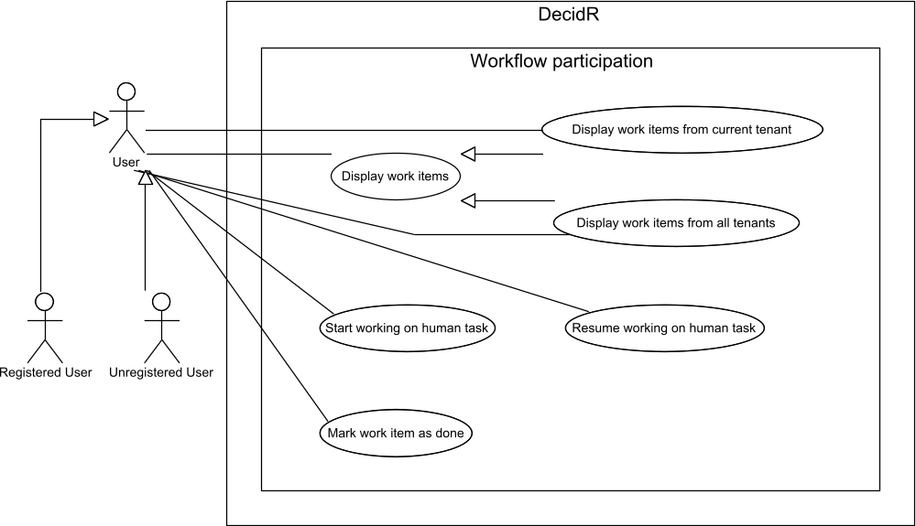

Figure 31: use case overview “workflow participation”

Display work items from current tenant
Priority | Must-have
Reference | Figure 7: my work items
Goal | The user wants to view his work items of the current tenant.
Precondition | The user has logged in.  The user is member of at least one tenant.
Basic flow | - The user clicks on the „My Work items” entry in the navigation bar or selects in the combo box on the work item page “current tenant”.  - The system displays a list of the user’s work items for the current tenant. For every work item the following data is displayed:  - Name  - Tenant  - Date received  - Status (new, in progress or done)  Work items with the status „new” are displayed with a link “work on item”. Work items with the status “in progress” are displayed with a link “work on item” and with a link „mark as done“.
Postcondition | The user can see the work items of the current tenant.  The user is logged in.

Display work items from all tenants
Priority | Must-have
Reference | Figure 7: my work items
Goal | The user wants to view his work items of all tenants.
Precondition | The user has logged in  The user is member of at least two tenants.
Basic flow | - Execute use case View list of tenant workflow models  - The user selects in the combo box on the work item page “all tenants”.  - The system displays a list of the user’s work items for all tenants. For every work item the following data is displayed:  - Name  - Tenant  - Date received  - Status (new, in progress or done)  - Work items with the status “new” are displayed with a link “work on item”. Work items with the status “in progress” are displayed with a link “work on item”and with a link “mark as done”.
Postcondition | The user can see the work items of the current tenant.  The user is logged in.

Start working on a work item
Priority | Must-have
Reference | Figure 7: my work items  Work Item Statuses
Goal | The user wants to start working on a work item.
Precondition | The user is member of at least one tenant.  The system displays the user’s work items.  At least one work item has the status „new“.
Basic flow | - The user clicks on the link “work on item” of that work item, he wishes to work on.  - The system opens a new window that contains one or more of the following items:  - Text fields  - Forms  - Input fields  - Content, Size and amount are defined by the tenant admin and the workflow admin. The window can also include the option to upload one or more files.  - The user fills out the forms, input fields and / or uploads a file.  - The user clicks on the “save” button.  - The system saves the state and inputs of the windows and closes the windows. The system changes the status of the work item to “in progress”.  - The system displays the user’s work items
Postcondition | The work item status is displayed as „in progress“.  State and inputs made by the user are saved into the system.  The user’s work items are shown.
Alternative flow | 5a. The user closes the window.  6a. The system discards all inputs and displays the user’s work items.
Alternative postcondition | The work item status is displayed as “new”.  The system displays a list of the user’s work items.

Resume working on a work item
Priority | Must-have
Reference | Figure 7: my work items  Work Item Statuses
Goal | The user wants resume work on a work item.
Precondition | The user is member of at least one tenant.  The system displays the user’s work items.  At least one work item has the status “in progress“.  The user is logged in.
Basic flow | - The user clicks on the link “work on item” next to the work item that has the status “in progress”.  - The system opens a new window that contains one or more of the following items:  - Text fields  - Forms  - Input fields  - Content, Size and amount are defined by the tenant admin and the workflow admin. The window can also include the option to upload a file. If available, the input fields are filled by the previously generated content of the user.  - The user fills out the forms, input fields and / or uploads one or more files.  - The user clicks on the “save” button.  - The system saves the state and inputs of the window and closes the window.
Postcondition | The work item status is displayed as “in progress”.  State and inputs done by the user are saved into the system.  The user is logged in.
Alternative flow | 5a. The user closes the window.  6a. The system discards all inputs and displays the user’s work items.
Alternative postcondition | The work item status is displayed as “in progress”.  The system displays a list of the user’s work items.

Mark work item as done
Priority | Must-have
Reference | Figure 7: my work items  Work Item Statuses
Goal | The user wants to mark a work item as done.
Precondition | The user is member of at least one tenant.  The system displays the user’s work items.  At least one work item has the status „in progress“.  The user is logged in.
Basic flow | - The user clicks on the link „mark as done” of that work item he or she wishes to mark as done.  - The system displays a dialog asking the user if he is sure he wants to mark the work item as done.  - The user clicks on the “yes” button.  - The system closes the dialog and marks the work item as done by changing the status from „in progress” to "done".
Postcondition | The work item status in displayed as „done“.  The user cannot work on that work item anymore.  The user is logged in.
Alternative flow | 3a. The user clicks on the “no” button.  4a. The system close the dialog.
Alternative postcondition | The work item status is displayed as “in progress”.  The system displays a list of the user’s work items.  The user can still work on that work item.  The user is logged in.

Workflow instance management
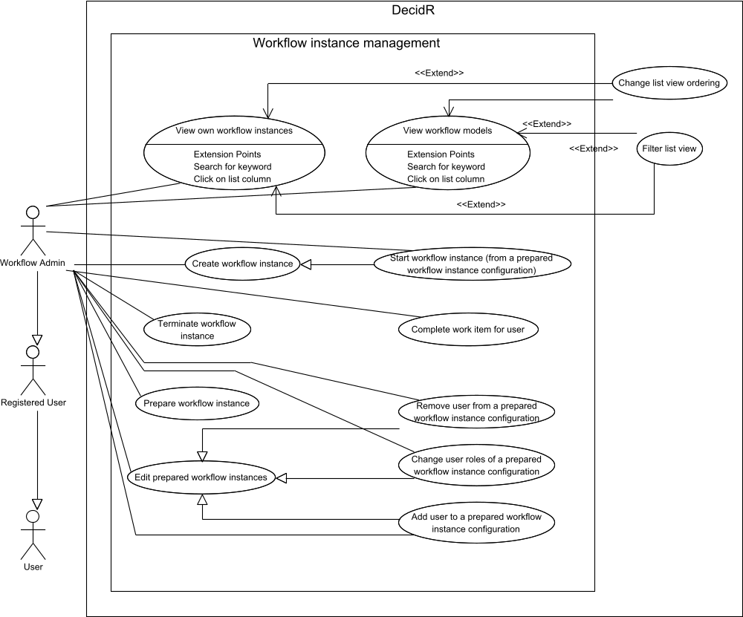

Figure 32: use case overview “workflow instance management”

View workflow models
Priority | Must-have
Reference | Figure 10: create workflow instance
Goal | The workflow admin wants to list the workflow models for which he has the workflow admin role.
Precondition | The workflow admin is logged in.
Basic flow | - The workflow admin clicks on the link “create instance” in the navigation bar.  - The system displays a page on which all workflow models of the workflow admin for the current tenant are listed.
Postcondition | A page with all workflow models of the workflow admin for the current tenant is shown.  The workflow admin is logged in.

View own workflow instances
Priority | Must-have
Reference | Figure 11: show workflow instances
Goal | The workflow admin wants to list his workflow instances.
Precondition | The workflow admin is logged in.
Basic flow | - The workflow admin clicks on the link “show workflow instances”.  - The system displays a list of all running and completed workflow instance the workflow admin has started.
Postcondition | A page with all workflow instances of the workflow admin is  shown.  The workflow admin is logged in.

Prepare workflow instance configuration
Priority | Nice-to-have
Reference | None.
Goal | The workflow admin wants to prepare an instance from a workflow model.
Precondition | The workflow admin is logged in.
Basic flow | - The workflow admin clicks on the link “create workflow instance”.  - The workflow admin selects a model from which he wants to create an instance and presses the “prepare” button.  - The workflow admin optionally invites or adds users to the instance (see Add user to a prepared workflow instance)  - The workflow admin presses the button “save”.  - The system shows a success page.
Postcondition | An instance of the workflow is created and set to the status prepared.  The workflow admin is logged in.

Create workflow instance
Priority | Must-have
Reference | Add user to a prepared workflow instance configuration  Remove user from a prepared workflow instance configuration  Change user roles of a prepared workflow instance configuration
Goal | The workflow admin wants to create an instance from a workflow model.
Precondition | The workflow admin is logged in.
Basic flow | - The workflow admin goes to the workflow model overview page  - The workflow admin selects a model from which he wants to create an instance and click on the link “start instance”.  - The system shows the workflow instance configuration interface.  - The workflow admin configures the workflow instance variables and roles (see referenced use cases).  - The workflow admin sets the startup options of the new workflow instance.  - The workflow admin presses the start button.  - The system checks if any of the workflow participants has set his status to unavailable. This is not the case.  - The system checks whether the workflow admin has selected “start when all invitations have been accepted” or “start immediately”. The workflow admin has selected “start immediately”.  - The system sends invitation e-mails to all workflow participants that aren’t already a member of the tenant, including unregistered users. If the workflow hasn’t selected “Users must register to participate”, the invitation e-mails contain a link that lets the receivers participate without creating a user profile.  - The system creates the BPEL process that represents the workflow instance and sets its status to running.  - The system displays the list of workflow instances in the web browser.
Postcondition | The workflow admin is logged in.  The system has created the BPEL process that represents the workflow instance and set its status to running.  The system has sent invitation e-mails to all workflow participants that aren’t already a member of the tenant, including unregistered users.  The web browser displays the list of workflow instances.
Alternative flow (1) | 7a. At least one workflow participant is unavailable.  8a. The system displays an error message.  9a. Continue with step 4.
Alternative flow (2) | 8a. The workflow admin has selected “start when all invitations have been accepted”.  9a. The system sends invitation e-mails to all workflow participants that aren’t already a member of the tenant, including unregistered users.  10a. The system creates the BPEL process that represents the workflow instance, but doesn’t start the process yet. It is started when all participants have confirmed their invitations. It is terminated if at least one participant rejects his invitation (see Confirm tenant membership invitation).  11a. The system displays the list of workflow instances in the web browser.
Alternative postcondition (2) | The workflow admin is logged in.  The system has created the BPEL process that represents the workflow instance, but hasn’t started the process yet.  The system has sent invitation e-mails to all workflow participants that aren’t already a member of the tenant, including unregistered users.  The web browser displays the list of workflow instances.

Start workflow instance (from a prepared workflow instance configuration)
Priority | Nice-to-have
Reference | Figure 10: create workflow instance
Goal | The workflow admin wants to start a prepared workflow instance.
Precondition | The workflow admin is logged in.  There is at least one workflow instance with the status “prepared”.
Basic flow | - The workflow admin goes to the workflow instance overview page, selects an instance which is in the prepared state and presses the edit link.  - The system shows the instance editing page.  - The workflow admin presses the button start instance.  - Execute use case Create workflow instance.
Postcondition | The instance of the workflow is started.  The workflow admin is logged in.

Change user roles of a prepared workflow instance configuration
Priority | Must-have
Reference | None.
Goal | The workflow admin wants to change the role of an already added user in a prepared workflow instance configuration.
Precondition | The workflow admin is logged in.  Editing page of an instance is shown.
Basic flow | - The system shows a page where all users are listed. Next to each user there is a combo box with the roles.  - The workflow admin changes the role of one or more users and presses the save button.  - The system changes the user roles.
Postcondition | The user roles of the users were changed.  The workflow admin is logged in.

Add user to a prepared workflow instance configuration
Priority | Must-have
Reference | None.
Goal | The workflow admin wants to add a user to a prepared workflow instance configuration.
Precondition | The workflow admin is logged in.  The system shows an editing page of an instance.
Basic flow | - The workflow admin presses the “add user” button.  - The system displays a page with an input field.  - The workflow admin enters a username or an email address that corresponds to an account which is member of the tenant and selects the role in the combo box.  - The system checks if an email address or a username is entered – result: username  - The system adds the user to the instance and sets the assigned role.
Postcondition | The user was added and corresponding role was set.  The workflow admin is logged in.
Alternative flow (1) | 4a. The system checks if an email address or a username is entered – result: email address  5a. If the email address is not registered, the system sends an email with a register link to the email address. After the user is registered, the system adds the user to the instance and sets the assigned role. If the email address is registered, the system adds the user with the corresponding email address to the instance and sets the assigned role.
Alternative flow (2) | 4a The system checks if an email address or a tenant user is entered – neither email address nor username.  5a. The system shows an error message.
Alternative postcondition (1) | The user was added and the corresponding role was set.  The workflow admin is logged in.
Alternative postcondition (2) | The user wasn’t added.  The workflow admin is logged in.

Remove user from a prepared workflow instance configuration
Priority | Must-have
Reference | None.
Goal | The workflow admin wants to remove a user from a workflow instance configuration.
Precondition | The workflow admin is logged in.  The web browser shows an editing page of a workflow instance configuration. The system shows a page where all users are listed. Next to each user there is a button “delete user”.
Basic flow | - The workflow admin clicks on one of the buttons.  - The system removes the user from the workflow instance configuration, so he will not become a participant.
Postcondition | The user is no longer part of the instance.  The workflow admin is logged in.

Complete work item for a user
Priority | Must-have
Reference | Figure 11: show workflow instances  Figure 7: my work items
Goal | The workflow admin wants to complete a work item for a user who is participating in a running workflow instance.
Precondition | The workflow admin is logged in.  There is at least one workflow instance which has the status “running” and the according workflow model contains human task activities.
Basic flow | - The workflow admin goes to the workflow instance overview page and selects a workflow instance which has the status “running”.  - The workflow admin presses the “show work items” button.  - The system displays a list of all work items which are associated with the selected workflow instance. The view is similar to the view described in “Display work items”. For each work item in the list, the system displays additionally the user to whom the work item was assigned to.  - The workflow admin starts or resumes working on a work item (see “Starting working on a work item” or “Resume working on a work item respectively”).  - The workflow admin marks the work item as done (see “Mark work item as done”).
Postcondition | The system displays the status of the work item as “done”.  Both the workflow admin and the user cannot work on that item.  The system sends a notification email to the user informing him that his work item has been completed by the workflow admin.

Terminate workflow instance
Priority | Must-have
Reference | Figure 11: show workflow instances
Goal | The workflow admin wants to terminate a running workflow instance.
Precondition | The workflow admin is logged in.
Basic flow | - The workflow admin goes to the workflow instance overview page and selects a workflow instance which has the status “running”.  - The workflow admin presses the button “terminate”.  - The system asks the workflow admin if the workflow instance should be terminated.  - The workflow admin clicks on the “yes” button.  - The system terminates the BPEL process that represents the workflow instance.
Postcondition | The workflow admin is logged in.  The BPEL process is terminated.
Alternative flow | 4a. The workflow admin clicks on the “no” button.
Alternative postcondition | The instance of the workflow isn’t terminated.  The workflow admin is logged in.

Tenant settings
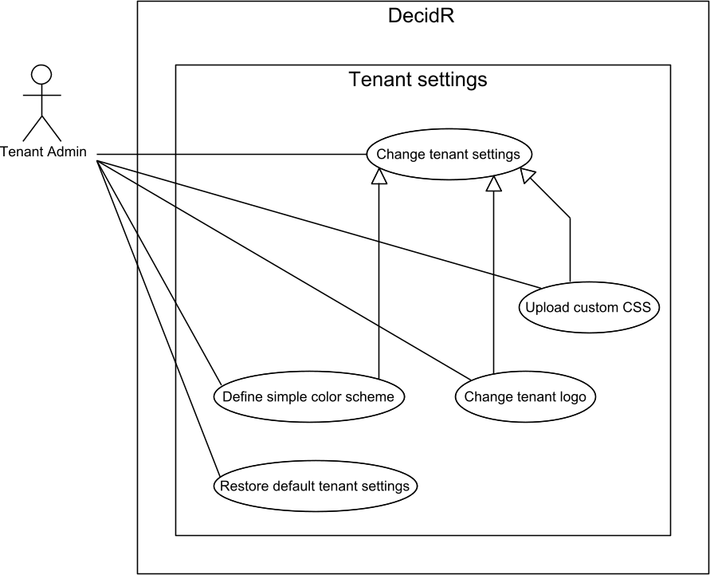

Figure 33: use case overview “tenant settings”

Change tenant settings
Priority | Must-have
Reference | Figure 15: tenant settings (simple)  Figure 16: tenant settings (advanced)
Goal | The tenant admin wants to change the tenant description, set a tenant logo or make changes to the tenant color scheme.
Precondition | The tenant admin is logged in.
Basic flow | - The tenant admin navigates to the tenant settings page by selecting “Tenant Settings” in the navigation bar. The system displays the current settings in the web browser.  - The tenant admin enters a new description text and optionally changes the tenant appearance settings (see specialized use cases).  - The tenant admin presses the save button.  - The system validates the new settings. All settings are valid.  - The system stores the new settings and displays the updated settings page in the web browser.
Postcondition | The tenant admin is logged in.  The system has written the new settings to the database.
Alternative flow (1) | 4a. The description text is too long (see User Input Constraints) or the appearance settings are invalid (see specialized use cases).  5a. The system displays an error message.  6a. Continue with step 2.
Alternative flow (2) | 3a. The tenant admin presses the cancel button.  4a. The system displays an info message telling the tenant admin that the settings haven’t been saved.  5a. The system displays the current tenant settings.
Alternative postcondition (2) | The tenant admin is logged in.  The system has discarded the new settings and the previous settings are still in effect.

Change tenant logo
Priority | Must-have
Reference | Figure 15: tenant settings (simple)  Figure 16: tenant settings (advanced)
Goal | The tenant admin wants to change the logo that is displayed to every user of the tenant once they’re logged in.
Precondition | The tenant admin is logged in.
Basic flow | - The tenant admin navigates to the tenant settings page by selecting “Tenant Settings” in the navigation bar.  - The system displays the current logo in the web browser.  - The tenant admin selects a file on his local system to use as the new tenant logo.  - The tenant admin presses the save button on the settings page.  - The system verifies the new settings submitted by the tenant admin. The new tenant logo is a valid image file (see User Input Constraints).  - If necessary, the system resizes the image so it doesn’t exceed the maximum tenant logo dimensions.  - The system overwrites the current tenant logo with the new image file.  - The system displays the updated tenant settings page in the web browser.
Postcondition | The tenant admin is logged in.  The tenant admin’s web browser displays the updated settings page.  The new tenant logo is displayed.
Alternative flow | 4a. The submitted file is too large or does not contain a valid image.  5a. The system displays an error message.  6a. Continue with step 3.

Upload custom CSS
Priority | Desirable
Reference | Figure 16: tenant settings (advanced)
Goal | The tenant admin wants to upload his own CSS file that defines the appearance of the web pages for all users of that tenant.
Precondition | The tenant admin is logged in.
Basic flow | - The tenant admin navigates to the tenant settings page by selecting “Tenant Settings” in the navigation bar.  - The system displays the current appearance settings.  - The tenant admin selects “show advanced options” if he hadn’t previously used a CSS file to define the tenant appearance. Otherwise the web browser already displays the CSS input box.  - The tenant admin enters his CSS code into the input box.  - The tenant admin presses the save button.  - The system successfully validates the CSS.  - The system overwrites the current tenant CSS file with the new custom CSS file.  - The system displays the updated settings page in the web browser.
Postcondition | The tenant admin is logged in.  The web browser displays the updated settings page.  The tenant web pages use the new color scheme.
Alternative flow | 6a. The CSS is not valid.  7a. The system displays an error message.  8a. Continue with step 4.

Define simple color scheme
Priority | Must-have
Reference | Figure 15: tenant settings (simple)
Goal | The tenant admin wants to change the tenant appearance using user-friendly color input boxes.
Precondition | The tenant admin is logged in.
Basic flow | - The tenant admin navigates to the tenant settings page by selecting “Tenant Settings” in the navigation bar.  - The system displays the current appearance settings.  - The tenant admin selects “show basic options” if he had previously used a CSS file to define the tenant appearance. The web browser displays the basic color scheme input boxes.  - The tenant admin uses the color input boxes to define the new color scheme.  - The tenant admin presses the save button.  - The system generates a CSS file from the user’s input, makes a backup copy of the user’s custom CSS for future use and overwrites the current tenant CSS file with the generated file.  - The system displays the updated settings page in the web browser.
Postcondition | The tenant admin is logged in.  The web browser displays the updated settings page.  The tenant web pages use the new color scheme.

Restore default tenant settings
Priority | Must-have
Reference | Figure 15: tenant settings (simple)
Goal | The tenant admin wants to restore the default tenant settings, including the tenant color scheme.
Precondition | The tenant admin is logged in.
Basic flow | - The tenant admin navigates to the tenant settings page by selecting “Tenant Settings” in the navigation bar.  - The system displays the current tenant settings in the web browser.  - The tenant admin presses the “Restore default settings” button.  - The system restores the default tenant settings.  - The system displays the updated settings page in the web browser.
Postcondition | The tenant admin is logged in.  The web browser displays the updated settings page.  The system has restored the default tenant settings.

Tenant user management
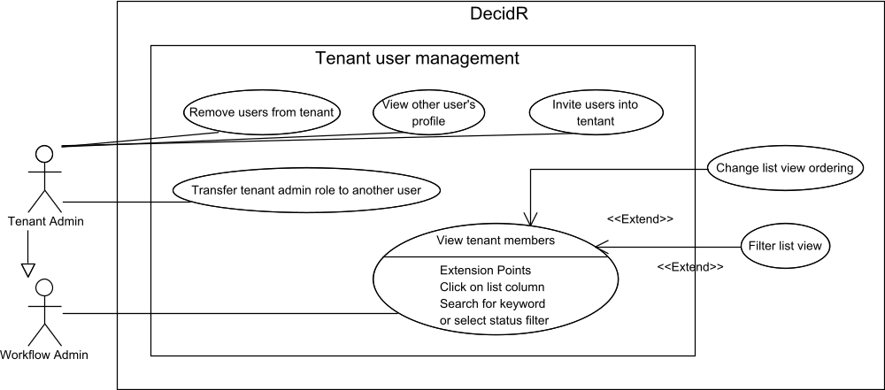

Figure 34: use case overview “tenant user management”

Invite users to tenant
Priority | Must-have
Reference | Figure 17: edit user list (tenant admin)
Goal | The tenant admin wants to send invitation e-mails to registered or unregistered users that allow the users to join the tenant as normal users.
Precondition | The tenant admin is logged in.
Basic flow | - The tenant admin navigates to the user administration page by selecting “Edit user list” in the navigation bar.  - The tenant admin navigates to the invitation sub-page.  - The tenant admin selects “invite user”.  - The system displays an input box in the web browser.  - The tenant admin enters a number of e-mail addresses and / or user names (see User Input Constraints).  - The tenant admin presses the send button.  - The system verifies the given e-mail addresses and usernames. All e-mail addresses are valid and all usernames denote registered DecidR users that aren’t already members of the tenant.  - The system sends invitation e-mails to the given e-mail addresses which it deduces from the usernames if necessary. If user profile information is available, the system uses it to enhance the content of the invitation (such as addressing the users with their actual name).  - The system displays a success message in the web browser.
Postcondition | The tenant admin is logged in.  The web browser displays a success message.  Invitation e-mails have been sent to the given e-mail addresses.  Every registered DecidR user receives at most one invitation e-mail.
Alternative flow (1) | 7a. At least one of the following errors occurs:  - At least one e-mail address is invalid.  - At least one username doesn’t denote a registered DecidR user.  - At least one e-mail address or username belongs to a registered user who is already a member of the tenant.  - The tenant admin submits too many usernames / e-mail addresses.  8a. The system displays an error message in the browser.  9a. Continue with step 5.

Remove users from tenant
Priority | Must-have
Reference | Figure 17: edit user list (tenant admin)
Goal | The tenant admin wants to remove one or more users from the tenant.
Precondition | The tenant admin is logged in.  There is at least one tenant member besides the tenant admin.
Basic flow | - The tenant admin navigates to the user administration by selecting “Edit users” in the navigation bar.  - The system displays a list of tenant members.  - The tenant admin selects one or more tenant members to remove.  - The tenant admin presses the remove button.  - The system displays a confirmation dialog in the web browser.  - The tenant admin confirms the removal.  - The system checks whether any of the users to remove can actually be removed. This is the case.  - The system revokes the tenant membership status of the selected users.  - The system displays the updated list of tenant members in the web browser.
Postcondition | The tenant admin is logged in.  The selected users are no longer members of the tenant, but may still be members of other tenants.  The web browser displays the updated list of tenant members.
Alternative flow (1) | 6a. The tenant admin cancels the removal.
Alternative postcondition (1) | The tenant admin is logged in.  There is at least one tenant member besides the tenant admin unless that tenant member has left the tenant in the mean time.
Alternative flow (2) | 7a. At least one tenant member cannot be removed because he has left the tenant on his own, is participating in a workflow, administrating the workflow, or is the tenant admin himself.  8a. The system displays an error message in the web browser. The tenant admin may continue with step 3.
Alternative postcondition (2) | The tenant admin is logged in.  The web browser displays an error message. The tenant admin may continue with step 3.  None of the selected tenant members have been removed.
Alternative flow (3) | 6a. The tenant has been deleted by the super admin.  7a. The system displays an error message in the web browser.
Alternative postcondition (3) | The web browser displays an error message.

View tenant members
Priority | Must-have
Reference | Figure 17: edit user list (tenant admin)
Goal | The workflow admin wants to view a list of tenant members.
Precondition | The workflow admin is logged in.
Basic flow | - The workflow admin navigates to the user administration by selecting “Users” in the navigation bar.  - The system displays a list of tenant members in the web browser using the default ordering.
Postcondition | The tenant admin is logged in.  The web browser displays a list of tenant members.

Transfer tenant admin role to another user
Priority | Nice-to-have
Reference | Figure 17: edit user list (tenant admin)
Goal | The tenant admin wants to transfer his role as tenant admin to another user.
Precondition | The tenant admin is logged in.  There is at least one user in the user list whose account is enabled an available.
Basic flow | - The tenant admin navigates to the user administration by selecting “User” in the navigation bar.  - The system displays a list of tenant members using the default ordering.  - The tenant admin selects one user and presses the “promote to tenant admin” button.  - The system displays a message asking the user if he his sure he wants to transfer his role as tenant admin to the selected user.  - The tenant admin presses the “yes” button.  - The system transfers all tenant admin rights and workflow models to the designated tenant admin.  - The system sends a notification email to the super admin and the designated tenant admin stating that the tenant admin role has been transferred.  - The system displays the start page.
Postcondition | The old tenant admin is logged in.  The old tenant admin’s navigation bar has only the entries of a normal user.  The new tenant admin own all workflow models the old tenant admin had.  The start page is displayed.

View other user’s profile
Priority | Desirable
Reference | Figure 17: edit user list (tenant admin)
Goal | The tenant admin wants to view the profile data of a tenant member.
Precondition | The tenant admin is logged in.
Basic flow | - The tenant admin navigates to the user administration by selecting “Users” in the navigation bar.  - The system displays the tenant member list.  - The tenant admin selects a tenant member.  - The system displays in the web browser:  - The tenant member’s profile data  - A list of workflow instances that tenant member is participating in  - A list of workflow models that are administrated by the tenant member
Postcondition | The tenant admin is logged in.  The web browser displays the tenant member’s profile data.
Alternative flow | 2a. The selected user is no longer a member of the tenant.  3a. The system displays an error message in the web browser.
Alternative postcondition | The tenant admin is logged in.

Workflow modeling
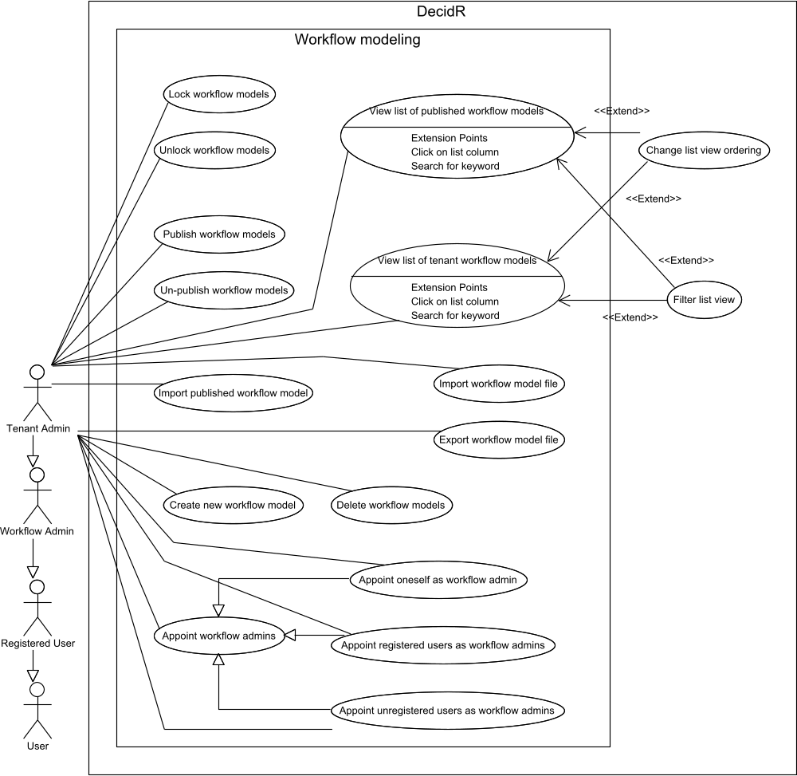

Figure 35: use case overview “workflow modeling”

Create new workflow model
Priority | Must-have
Reference | Figure 13: workflow model view (current tenant)  Open existing workflow model for editing
Goal | The tenant admin wants to create a new workflow model.
Precondition | The tenant admin is logged in.
Basic flow | - The tenant admin navigates to the workflow modeling section by clicking on the “create / edit workflow models” navigation link.  - The system displays a list of workflow models in the web browser.  - The tenant admin presses the “Create new model” button.  - The system displays an input box named “New workflow model name”.  - The tenant admin enters a workflow model name and presses the OK button.  - The system successfully validates the given name (see User Input Constraints).  - The system creates a new workflow model with the given name.  - The system displays the new workflow model in the workflow model editor.
Postcondition | The tenant admin is logged in.  The system has created a new unlocked workflow model with the given name.  The web browser displays the workflow model editor where the new workflow model has been opened for editing.
Alternative flow | 6a. The given name is invalid.  7a. The system displays an error message in the web browser. Continue with step 5.

Delete workflow models
Priority | Must-have
Reference | Figure 13: workflow model view (current tenant)
Goal | The tenant admin wants to delete one or more of his workflow models.
Precondition | The tenant admin is logged in.  The tenant owns at least one workflow model.
Basic flow | - The tenant admin navigates to the workflow modeling section by clicking on the “create / edit workflow models” navigation link.  - The system displays a list of workflow models in the web browser.  - The tenant admin selects one or more workflow models to delete.  - The tenant admin presses the remove button.  - The system displays a confirmation dialog in the web browser.  - The tenant admin confirms the deletion.  - The system removes the selected workflow models, but keeps all workflow instances that have been created from the deleted model.  - The system displays the updated workflow model list in the web browser.
Postcondition | The tenant admin is logged in.  The selected workflow models have been deleted.  The web browser displays the updated workflow model list.
Alternative flow (1) | 6a. The tenant admin cancels the deletion.
Alternative postcondition (1) | The tenant admin is logged in.  The selected workflow models still exist.  The web browser displays the workflow model list.
Alternative flow (2) | 7a. At least one selected workflow model cannot be deleted because it doesn’t exist anymore.  8a. The system ignores the non-existent model and deletes the remaining selected workflow models. Continue with step 8.

Lock workflow models
Priority | Must-have
Reference | Figure 13: workflow model view (current tenant)
Goal | The tenant admin wants to lock his existing workflow models so no new instances can be created from them until they are unlocked.
Precondition | The tenant admin is logged in.  The tenant owns at least one workflow model.
Basic flow | - The tenant admin navigates to the workflow modeling page by clicking on the “create / edit workflow models” navigation link.  - The system displays a list of workflow models in the web browser.  - The tenant admin selects a set of workflow models to lock.  - The tenant admin presses the lock button.  - The system locks each selected workflow model.  - The system displays the updated workflow modeling page in the web browser.
Postcondition | The tenant admin is logged in.  The web browser displays the updated workflow model list.  No new workflow instances can be created from the selected workflow models.
Alternative flow (1) | 5a. At least one of the selected workflow models doesn’t exist anymore.  6a. The system ignores the nonexistent workflow models and locks the remaining ones. Continue with step 6.

Unlock workflow models
Priority | Must-have
Reference | Figure 13: workflow model view (current tenant)
Goal | The tenant admin wants to unlock his existing workflow models so new instances can be created from them.
Precondition | The tenant admin is logged in.  The tenant owns at least one workflow model.
Basic flow | - The tenant admin navigates to the workflow modeling page by clicking on the “create / edit workflow models” navigation link.  - The system displays a list of workflow models in the web browser.  - The tenant admin selects a set of workflow models to unlock.  - The tenant admin presses the unlock button.  - The system unlocks each selected workflow model.  - The system displays the updated workflow modeling page in the web browser.
Postcondition | The tenant admin is logged in.  The web browser displays the updated workflow model list.  New workflow instances can be created from the selected workflow models.
Alternative flow (1) | 5a. At least one of the selected workflow models doesn’t exist anymore.  6a. The system ignores the nonexistent workflow models and unlocks the remaining ones. Continue with step 6.

Import workflow model file
Priority | Nice-to-have
Reference | None
Goal | The tenant admin wants to add a workflow model from a file that is stored on his computer.
Precondition | The tenant admin is logged in.
Basic flow | - The tenant admin navigates to the workflow modeling section by clicking on the “create / edit workflow models” navigation link.  - The system displays a list of workflow models in the web browser.  - The tenant admin clicks the “Import from file” link.  - The system displays a page with a file upload input box.  - The tenant admin chooses a file to upload from his local computer.  - The tenant admin presses the “upload” button.  - The system analyzes the uploaded file and checks whether it contains a valid workflow model. This is the case.  - The system adds the uploaded workflow model to the tenant.  - The system shows a confirmation page.
Postcondition | The tenant admin is logged in.  The system has added the uploaded workflow model to the tenant.
Alternative flow | 7a. The system detects that the uploaded file does not contain a valid workflow model.  8a. The system displays an error message in the web browser.  9a. Continue with step 5.

Export workflow model file
Priority | Nice-to-have
Reference | None
Goal | The tenant admin wants to download a workflow model as a single file.
Precondition | The tenant admin is logged in.  The tenant owns at least one workflow model.
Basic flow | - The tenant admin navigates to the workflow modeling section by clicking on the “create / edit workflow models” navigation link.  - The system displays a list of workflow models in the web browser.  - The tenant admin clicks the “download” link next to the workflow model that he wants to download.  - The system creates a file representation of the selected workflow model and sends it to the tenant admin.
Postcondition | The tenant admin is logged in.  The system has sent the selected workflow model to the tenant admin as a file download.

Import published workflow model
Priority | Must-have
Reference | Figure 14: workflow model view (public models)  View list of published workflow models
Goal | The tenant admin wants to import a published workflow model so he may edit them and start new workflow instances from them.
Precondition | The tenant admin is logged in.  The web browser is displaying the list of published workflow models (see View list of published workflow models).
Basic flow | - The tenant admin selects the published workflow model to import.  - The tenant admin presses the import button.  - The system creates a copy of the selected workflow model that is owned by the tenant admin.  - The system displays the list of published workflow models along with a success message.
Postcondition | The tenant admin is logged in.  The web browser displays the list of published workflow models and a success message.  The system has added an unlocked copy of the published workflow model to the tenant’s list of workflow models.

Publish workflow models
Priority | Must-have
Reference | Figure 13: workflow model view (current tenant)
Goal | The tenant admin wants to publish one or more of his workflow models, so other tenant admins may view and import them.
Precondition | The tenant admin is logged in.
Basic flow | - The tenant admin navigates to the workflow modeling page by clicking on the “create / edit workflow models” navigation link.  - The system displays a list of workflow models in the web browser.  - The tenant admin selects a set of workflow models to publish.  - The tenant admin presses the publish button.  - The system flags the selected workflow models as published.  - The system displays the updated list of workflow models in the web browser.
Postcondition | The tenant admin is logged in.  The web browser displays the updated list of workflow models that the tenant admin owns.  The selected workflow models are now visible to other tenant admins, who may view or import them.

Un-publish workflow models
Priority | Must-have
Reference | Figure 13: workflow model view (current tenant)
Goal | The tenant admin wants to un-publish one or more of his workflow models, so other tenant admins can no longer view and import them.
Precondition | The tenant admin is logged in.
Basic flow | - The tenant admin navigates to the workflow modeling page by clicking on the “create / edit workflow models” navigation link.  - The system displays a list of workflow models in the web browser.  - The tenant admin selects a set of workflow models to un-publish.  - The tenant admin presses the un-publish button.  - The system removes the published flag from each selected workflow model.  - The system displays the updated list of workflow models in the web browser.
Postcondition | The tenant admin is logged in.  The web browser displays the updated list of workflow models that the tenant admin owns.  The selected workflow models are no longer visible to other tenant admins, nor can they be imported.

View list of tenant workflow models
Priority | Must-have
Reference | Figure 13: workflow model view (current tenant)
Goal | The tenant admin wants to view a list of workflow models that he owns.
Precondition | The tenant admin is logged in.
Basic flow | - The tenant admin navigates to the workflow modeling page by clicking on the “create / edit workflow models” navigation link.  - The system displays a list of workflow models in the web browser.
Postcondition | The tenant admin is logged in.  The web browser displays the list of workflow models that the tenant admin owns.

View list of published workflow models
Priority | Must-have
Reference | Figure 14: workflow model view (public models)
Goal | The tenant admin wants to view a list of workflow models which are not owned by the tenant, but have been published by other tenants.
Precondition | The tenant admin is logged in.
Basic flow | - The tenant admin navigates to the workflow modeling page by clicking on the “create / edit workflow models” navigation link.  - The system displays a list of workflow models in the web browser.  - The tenant admin clicks on the “Other tenants” tab.  - The system displays a list of workflow models that have been published by other tenants.
Postcondition | The tenant admin is logged in.  The web browser displays the list of published workflow.

Appoint workflow admins
Priority | Must-have
Reference | Figure 13: workflow model view (current tenant)  Appoint oneself as workflow admin  Appoint registered users as workflow admins  Appoint unregistered users as workflow admins
Goal | The tenant admin wants to designate one or more users as the workflow administrators for a particular workflow model.
Precondition | The tenant admin is logged in.  The tenant admin owns at least one workflow model.
Basic flow | - The tenant admin navigates to the workflow models page by selecting “Models” in the navigation bar.  - The system displays a list of the tenant’s workflow models in the web browser.  - The tenant admin selects a workflow model and then chooses “appoint workflow admins”.  - The system displays an input box in the web browser.  - The tenant admin chooses from one of the following options:  - Appoint oneself as the workflow admin.  - Enter the usernames of registered DecidR users.  - Enter the e-mail addresses of the desired workflow admins.  - The tenant admin presses the OK button.  - The system processes the tenant admin’s input (see specialized use cases).
Postcondition | The tenant admin is logged in.  The tenant admin has created at least one workflow model.  The postconditions of the specialized use cases apply.
Alternative flow (1) | 6a. The workflow model doesn’t exist anymore.  7a. The system displays an error message in the web browser.
Alternative postcondition (1) | The web browser displays an error message.  The postconditions of the specialized use cases apply.
Alternative flow (2) | 7a. The tenant admin has entered too many e-mail addresses (see User Input Constraints).  8a. The system displays an error message in the web browser.
Alternative postcondition (2) | The web browser displays an error message.  The tenant admin is logged in.  The postconditions of the specialized use cases apply.

Appoint oneself as workflow admin
Priority | Must-have
Reference | Figure 13: workflow model view (current tenant)
Goal | The tenant admin wants to designate himself as the only workflow administrator for a particular workflow model.
Precondition | The tenant admin is logged in.  The tenant admin owns at least one workflow model.
Basic flow | - The tenant admin navigates to the workflow models page by selecting “Models” in the navigation bar.  - The system displays a list of the tenant’s workflow models in the web browser.  - The tenant admin selects a workflow model and then chooses “appoint workflow admins”.  - The system displays an input box in the web browser.  - The tenant admin chooses “just me” as the workflow admin.  - The tenant admin presses the OK button.  - The system makes the tenant admin the only workflow admin of the selected workflow model.  - The system displays the updated workflow models page.
Postcondition | The tenant admin is logged in.  The tenant admin has created at least one workflow model.  The tenant admin is the only workflow admin of the selected workflow model.

Appoint registered users as workflow admins
Priority | Must-have
Reference | Figure 13: workflow model view (current tenant)
Goal | The tenant admin wants to designate registered users as the workflow administrators for a particular workflow model.  There is at least one tenant member besides the tenant admin.
Precondition | The tenant admin is logged in.  The tenant admin has created at least one workflow model.  There is at least one tenant member besides the tenant admin.
Basic flow | - The tenant admin navigates to the workflow models page by selecting “Models” in the navigation bar.  - The system displays a list of the tenant’s workflow models in the web browser.  - The tenant admin selects a workflow model and then chooses “appoint workflow admin”.  - The system displays an input box in the web browser.  - The tenant admin enters the usernames of registered users or selects members of the tenant.  - The tenant admin presses the OK button.  - The system sends an e-mail to each specified registered user. If the registered user is already a member of the tenant, the e-mail simply informs the user about his workflow admin status. Otherwise, each registered user must confirm joining the tenant first by following a link that is included in the e-mail.  - The system displays the updated workflow models page.
Postcondition | The tenant admin is logged in.  There is at least one tenant member besides the tenant admin.  The tenant admin has created at least one workflow model.  For each registered user: if the specified registered user is a member of the tenant:  - The tenant member is the workflow admin of the selected workflow model.  - The system has sent an info e-mail to the tenant member.  Otherwise:  - The system has sent an invitation e-mail that allows the registered user to become the workflow admin for the selected workflow model upon joining the tenant.  - The system hasn’t changed the workflow admin of the selected workflow model yet
Alternative flow | 7a. At least one given username does not belong to a registered user or the registered user has set his status to “unavailable”.  8a. The system displays an error message in the web browser. Continue with step 5.

Appoint unregistered users as workflow admins
Priority | Must-have
Reference | Figure 13: workflow model view (current tenant)
Goal | The tenant admin wants to designate users of whom he only knows the e-mail addresses as the workflow administrators for a particular workflow model.
Precondition | The tenant admin is logged in.  The tenant admin owns at least one workflow model.
Basic flow | - The tenant admin navigates to the workflow models page by selecting “Models” in the navigation bar.  - The system displays a list of the tenant’s workflow models in the web browser.  - The tenant admin selects a workflow model and then chooses “appoint workflow admins”.  - The system displays an input box in the web browser.  - The tenant admin enters some e-mail addresses (see User Input Constraints).  - The tenant admin presses the OK button.  - The system verifies each given e-mail addresses. They are valid and do not belong to a registered user.  - The system sends in invitation e-mail to the given address.  - The system displays the updated workflow models page.
Postcondition | The tenant admin is logged in.  The tenant admin has created at least one workflow model.  The system has sent e-mails containing an invitation links to the given addresses.  The system hasn’t changed the workflow admin of the selected workflow model yet
Alternative flow (1) | 7a. A given e-mail address belongs to a registered user.  8a. Continue with step 7 of “Appoint registered users as workflow admins”.
Alternative flow (2) | 7a. The e-mail address is invalid.  8a. The system displays an error message. Continue with step 5.

Workflow model editor
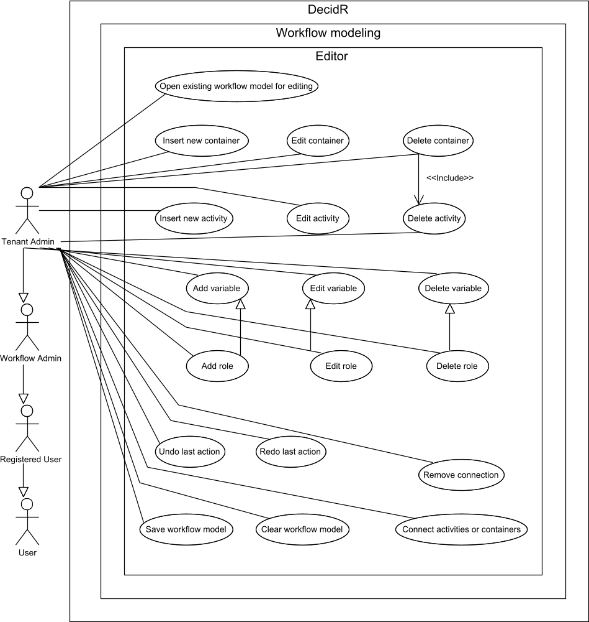

Figure 36: use case overview “workflow model editor”

Open existing workflow model for editing
Priority | Must-have
Reference | Figure 13: workflow model view (current tenant)
Goal | The tenant admin wants to open the workflow model editor in order to start modifying an existing workflow model.
Precondition | The tenant admin is logged in.  The tenant owns at least one workflow model.
Basic flow | - The tenant admin navigates to the workflow modeling page by clicking on the “Create / Edit Workflow Models” navigation link.  - The system displays a list of workflow models in the web browser.  - The tenant admin clicks on the “Edit” link next to the workflow model he wants to edit.  - The system opens the workflow model editor in the web browser showing the selected workflow model.
Postcondition | The tenant admin is logged in.  The tenant owns at least one workflow model.  The web browser displays the selected workflow model in the editor.
Alternative flow | 4a. The selected workflow model doesn’t exist anymore.  5a. The system displays an error message in the web browser.
Alternative postcondition | The web browser displays an error message.

Save workflow model
Priority | Must-have
Reference | None.
Goal | The tenant admin wants to save the changes he has made to a workflow model.
Precondition | The tenant admin is logged in.  The tenant admin has opened an existing workflow for editing.
Basic flow | - The tenant admin presses the save button in the editor.  - The system saves the modified workflow model.  - The tenant admin may continue editing the workflow model.
Postcondition | The tenant admin is logged in.  The system has saved the modified workflow model.  The web browser is displaying the workflow model editor.
Alternative flow (1) | 2a. The system cannot save the workflow model because it has been deleted or it contains invalid data.  3a. The system displays an error message in the web browser.
Alternative postcondition (1) | The tenant admin is logged in.  The web browser displays an error message.
Alternative flow (2) | 2a. The system cannot save the workflow model because it belongs to another tenant and has been published.  3a. The system displays a dialog in the web browser asking the tenant admin if the workflow model should be imported.  4a. The tenant admin confirms.  5a. The system saves the published workflow including all modifications made by the tenant admin as a new workflow model that is owned by the tenant.
Alternative postcondition (2) | The tenant admin is logged in.  The system has saved the modified workflow model as a new tenant-owned model.  The system hasn’t changed the published workflow model that was initially opened for editing.  The tenant admin is now editing the imported workflow model.
Alternative flow (2-1) | 4aa. The tenant admin cancels.
Alternative postcondition (2-1) | The tenant admin is logged in.  The system hasn’t changed the published workflow model.  The system hasn’t created a new tenant-owned workflow model.

Clear workflow model
Priority | Must-have
Reference | None.
Goal | The tenant admin wants to remove all activities, containers, connections and variables from the currently opened workflow model and start from scratch.
Precondition | The tenant admin is logged in.  The tenant admin has opened an existing workflow for editing.  The workflow model has exactly one start activity and exactly one end activity.
Basic flow | - The tenant admin presses the clear button.  - The system displays a confirmation dialog.  - The tenant admin confirms clearing the model.  - The editor deletes all activities, containers, connections and variables in the currently opened workflow model, and then recreates the start and end activities with default values.  - The tenant admin may continue editing the workflow model.
Postcondition | The tenant admin is logged in.  The tenant admin has opened an existing workflow for editing.  The editor has deleted all activities, containers, connections and variables.  The workflow model has exactly one start activity and exactly one end activity.  The system hasn’t saved the cleared workflow model.
Alternative flow | 3a. The tenant admin cancels clearing the model.
Alternative postcondition | The tenant admin is logged in.  The tenant admin has opened an existing workflow for editing.  The editor hasn’t deleted any activities, containers, variables or connections.  The workflow model has exactly one start activity and exactly one end activity.

Insert new activity
Priority | Must-have
Reference | None.
Goal | The tenant admin wants to insert one of the available activities into the workflow model.
Precondition | The tenant admin is logged in.  The tenant admin has opened an existing workflow for editing.
Basic flow | - The tenant admin drags an activity icon from the palette onto the canvas.  - The editor adds the new activity to the workflow model and opens its properties for editing.
Postcondition | The tenant admin is logged in.  The tenant admin has opened an existing workflow for editing.  The editor displays the properties of the new activity.  The workflow model contains the new activity.

Insert new container
Priority | Must-have
Reference | None.
Goal | The tenant admin wants to insert one of the available containers into the workflow model.
Precondition | The tenant admin is logged in.  The tenant admin has opened an existing workflow for editing.
Basic flow | - The tenant admin drags a container icon from the palette onto the canvas.  - The editor adds the new container to the workflow model and opens its properties for editing.
Postcondition | The tenant admin is logged in.  The tenant admin has opened an existing workflow for editing.  The editor displays the properties of the new container.  The workflow model contains the new container.

Edit activity
Priority | Must-have
Reference | None.
Goal | The tenant admin wants to edit the properties of an activity.
Precondition | The tenant admin is logged in.  The tenant admin has opened an existing workflow for editing.
Basic flow | - The tenant admin clicks on the box representing the activity.  - The system displays the current properties of the selected activity in the property editor.  - The tenant admin enters new valid properties.  - The tenant admin closes the property editor by pressing the save button.  - The editor overwrites the current properties of the selected activity with the new ones.
Postcondition | The tenant admin is logged in.  The tenant admin has opened an existing workflow for editing.  The editor has overwritten the old activity properties with the new ones.
Alternative flow (1) | 3a. The tenant admin enters at least one invalid property.  4a. The editor highlights the invalid property.  5a. Continue with step 3.
Alternative flow (2) | 4a. The tenant admin closes the property editor by pressing the discard button.  5a. The editor discards the new properties.
Alternatvive Postcondition (2) | The tenant admin is logged in.  The tenant admin has opened an existing workflow for editing.  The editor has discarded new properties. The activity still has its previous properties.

Edit container
Priority | Must-have
Reference | None.
Goal | The tenant admin wants to edit the properties of a container.
Precondition | The tenant admin is logged in.  The tenant admin has opened an existing workflow for editing.  The workflow model contains at least one container.
Basic flow | - The tenant admin clicks on the box representing the container.  - The system displays the current properties of the selected container in the property editor.  - The tenant admin enters new valid properties.  - The tenant admin closes the property editor by pressing the save button.  - The editor overwrites the current properties of the selected container with the new ones.
Postcondition | The tenant admin is logged in.  The tenant admin has opened an existing workflow for editing.  The editor has overwritten the old container properties with the new ones.
Alternative flow (1) | 3a. The tenant admin enters at least one invalid property.  4a. The editor highlights the invalid property.  5a. Continue with step 3.
Alternative flow (2) | 4a. The tenant admin closes the property editor by pressing the discard button.  5a. The editor discards the new properties.
Alternatvive Postcondition (2) | The tenant admin is logged in.  The tenant admin has opened an existing workflow for editing.  The editor has discarded new properties. The container still has its previous properties.

Delete activity
Priority | Must-have
Reference | None.
Goal | The tenant admin wants to remove an activity from the workflow model.
Precondition | The tenant admin is logged in.  The tenant admin has opened an existing workflow for editing.  The workflow model contains exactly one start activity and exactly one end activity.
Basic flow | - The tenant admin selects the box representing the activity to delete.  - The tenant admin presses the delete button or presses the delete key on his keyboard.  - If the editor is displaying the properties of the activity to delete, it closes the property editor without accepting the changes.  - The editor removes the selected activity as well as its incoming and outgoing connections.
Postcondition | The tenant admin is logged in.  The tenant admin has opened an existing workflow for editing.  The editor has removed the selected activity as well as its incoming and outgoing connections.  The workflow model contains exactly one start activity and exactly one end activity.
Alternative flow | 3a. The tenant admin is deleting the start or end activity.  4a. The editor aborts the delete action.
Alternative postcondition | The tenant admin is logged in.  The tenant admin has opened an existing workflow for editing.  The editor has removed the selected activity as well as its incoming and outgoing connections.  The workflow model contains exactly one start activity and exactly one end activity.

Delete container
Priority | Must-have
Reference | Delete activity
Goal | The tenant admin wants to remove a container and all activities it contains from a workflow model.
Precondition | The tenant admin is logged in.  The tenant admin has opened an existing workflow for editing.  The workflow model contains at least one container.
Basic flow | - The tenant admin selects the box representing the container to delete.  - The tenant admin presses the delete button or presses the delete key on his keyboard.  - If the editor is displaying the properties of the container to delete, it closes the property editor without accepting the changes.  - The editor removes the selected container, the activities it contains and its incoming and outgoing connections.
Postcondition | The tenant admin is logged in.  The tenant admin has opened an existing workflow for editing.  The editor has removed the selected container, the activities it contained and its incoming and outgoing connections.

Add variable
Priority | Must-have
Reference | None.
Goal | The tenant admin wants to add a new global variable or a role to a workflow model.
Precondition | The tenant admin is logged in.  The tenant admin has opened an existing workflow for editing.
Basic flow | - The tenant presses the add button in the variables list.  - The editor adds a new variable and opens its properties for editing.
Postcondition | The tenant admin is logged in.  The tenant admin has opened an existing workflow for editing.  The editor is displaying the properties of the new variable.

Edit variable
Priority | Must-have
Reference | None.
Goal | The tenant admin wants to edit an existing global variable or a role in a workflow model
Precondition | The tenant admin is logged in.  The tenant admin has opened an existing workflow for editing.  The workflow model contains at least one variable or role.
Basic flow | - The tenant admin clicks on a variable name in the variables list or presses the edit button for a selected variable.  - The editor displays the properties of the variable in the property editor.  - The tenant admin enters new valid properties.  - The tenant admin closes the property editor.  - The editor overwrites the old properties of the selected variable with the new ones.
Postcondition | The tenant admin is logged in.  The tenant admin has opened an existing workflow for editing.  The editor has overwritten the old properties of the selected variable with the new ones.
Alternative flow | 3a. At least one new property value is invalid.  4a. The editor highlights the invalid property.  5a. Continue with step 3.

Delete variable
Priority | Must-have
Reference | None.
Goal | The tenant admin wants to delete an existing global variable or a role from the workflow model.  The workflow model contains at least one variable.
Precondition | The tenant admin is logged in.  The tenant admin has opened an existing workflow for editing.
Basic flow | - The tenant admin selects the variable to delete in the variables list.  - The tenant admin presses the delete button.  - The editor removes the selected variable.
Postcondition | The tenant admin is logged in.  The tenant admin has opened an existing workflow for editing.  The editor has removed the selected variable from the workflow model.

Connect activities or containers
Priority | Must-have
Reference | None.
Goal | The tenant admin wants to define the order in which activities are executed.
Precondition | The tenant admin is logged in.  The tenant admin has opened an existing workflow for editing.
Basic flow | - The tenant admin clicks on the first port.  - The tenant admin clicks on the second port.  - The editor adds a connection between the selected ports.
Postcondition | The tenant admin is logged in.  The tenant admin has opened an existing workflow for editing.  The editor has added a connection between the selected ports.
Alternative flow (1) | 3a. The tenant admin is trying to connect two incoming ports or two outgoing ports.  4a. The editor displays a dialog informing the tenant admin that only incoming ports can be connected to outgoing ports and vice versa.
Alternative postcondition (1) | The tenant admin is logged in.  The tenant admin has opened an existing workflow for editing.  The editor hasn’t changed the connections between the selected ports.
Alternative flow (2) | 3a. There is already a connection between the selected ports.  4a. The editor displays a confirmation dialog asking the tenant admin whether to replace the existing connection.  5a. The tenant admin confirms.  6a. The editor removes the existing connections and adds a new connection.
Alternative postcondition (2) | The tenant admin is logged in.  The tenant admin has opened an existing workflow for editing.  The editor has removed the previous connections and has added a connection between the selected ports.
Alternative flow (2-1) | 5aa. The tenant admin declines.
Alternative postcondition (2-1) | The tenant admin is logged in.  The tenant admin has opened an existing workflow for editing.  The editor hasn’t changed any connections between the selected ports.
Alternative flow (3) | 2a. The tenant admin cancels connecting the activity by right-clicking or by clicking on an empty part of the editor canvas.
Alternative postcondition (3) | The tenant admin is logged in.  The tenant admin has opened an existing workflow for editing.  The editor hasn’t changed any connections between the selected port(s).

Undo last action
Priority | Must-have
Reference | None.
Goal | The tenant admin wants to undo the changes made to the workflow model by his last action.
Precondition | The tenant admin is logged in.  The tenant admin has opened an existing workflow for editing.  The last action can be undone.
Basic flow | - The tenant admin presses the undo button.  - The editor restores the older workflow model state.
Postcondition | The tenant admin is logged in.  The tenant admin has opened an existing workflow for editing.  The editor has restored the older workflow model state.

Redo last action
Priority | Must-have
Reference | None.
Goal | The tenant admin wants to restore the changes made to the workflow model which have been undone.
Precondition | The tenant admin is logged in.  The tenant admin has opened an existing workflow for editing.  The tenant admin has undone at least one action without making changes to the workflow model afterwards.
Basic flow | - The tenant admin presses the redo button.  - The editor restores the newer workflow model state.
Postcondition | The tenant admin is logged in.  The tenant admin has opened an existing workflow for editing.  The editor has restored the newer workflow model state.

Tenant monitoring
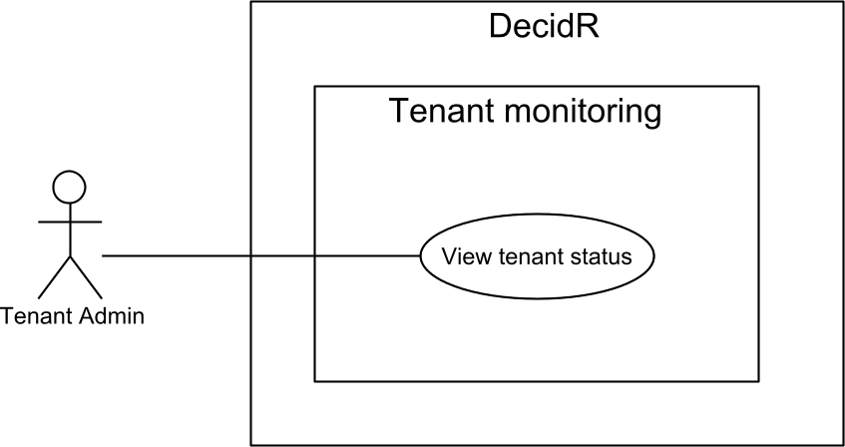

Figure 37: use case overview “tenant monitoring”

View tenant status
Priority | Nice-to-have
Reference | None.
Goal | The tenant admin wants to receive some interesting tenant statistics.
Precondition | The tenant admin is logged in.
Basic flow | - The tenant admin navigates to the tenant status page by selecting “Tenant Status” in the navigation menu.  - The system displays the tenant status page containing:  - Number of registered and unregistered users  - Total number of workflow models  - Total number of completed workflow instances  - Total number of aborted / terminated workflow instances
Postcondition | The tenant admin is logged in.  The web browser displays the tenant status page.
Alternative flow | 2a. The tenant has been deleted by the super admin.  3a. The system displays an error message in the web browser.
Alternative postcondition | The web browser displays an error message.

System settings
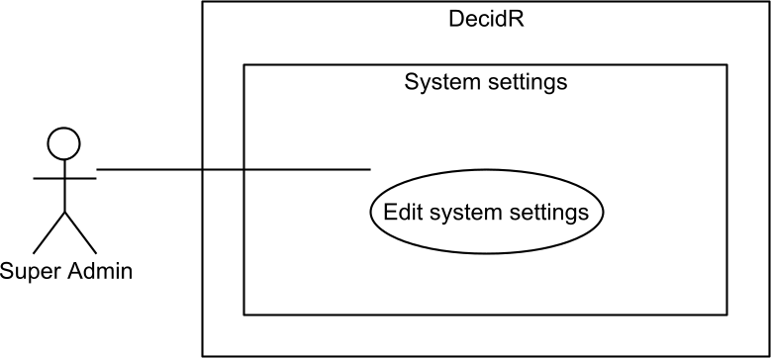

Figure 38: use case overview “system settings”

Edit system settings
Priority | Must-have
Reference | Figure 20: system settings
Goal | The super admin wants to edit the global system settings.
Precondition | The super admin is logged in.
Basic flow | - The super admin navigates to the system settings page by selecting “System Settings” in the administration navigation menu.  - The system displays the current settings in the web browser:  - Whether the super admin must confirm all new tenants or they are accepted automatically.  - Amount of logging to perform.  - The super admin enters the new settings.  - The super admin presses the save button.  - The system successfully validates the new settings.  - The system stores the new settings.  - The system displays the updated settings page in the web browser.
Postcondition | The super admin is logged in.  The system has applied the new settings.  The web browser displays the updated settings page.
Alternative flow | 5a. The new settings are invalid.  6a. The system displays an error message in the web browser. Continue with step 3.

System status
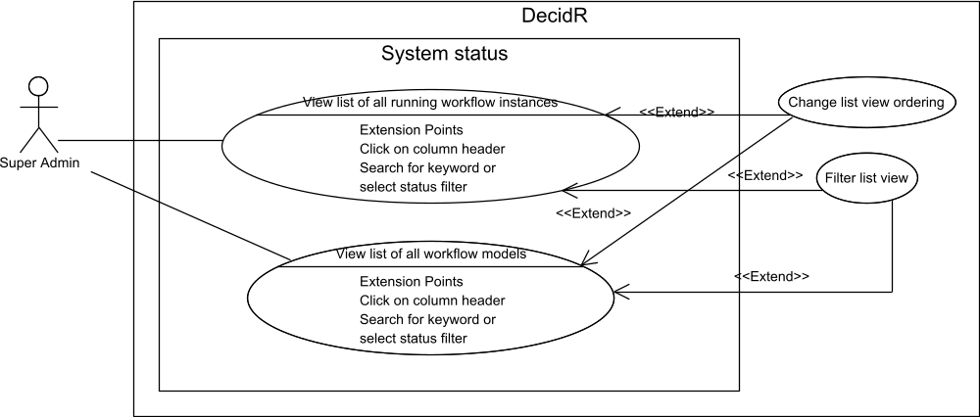

Figure 39: use case overview “system status”

View list of all workflow models
Priority | Nice-to-have
Reference | None.
Goal | The super admin wants to view a list of all workflow models in the system.
Precondition | The super admin is logged in.
Basic flow | - The super admin navigates to the workflow model overview by selecting “Models” in the administration navigation menu.  - The system displays a list of all workflow models coming from all tenants in the system, including the default tenant.
Postcondition | The web browser displays a list of all workflow models.

View list of all running workflow instances
Priority | Nice-to-have
Reference | None.
Goal | The super admin wants to view a list of all running workflow instances in the system.
Precondition | The super admin is logged in.
Basic flow | - The super admin navigates to the workflow model overview by selecting “Instances” in the administration navigation menu.  - The system displays a list of all running workflow instances coming from all tenants in the system, including the default tenant.
Postcondition | The web browser displays a list of all running workflow instances.  The super admin is logged in.

User Management
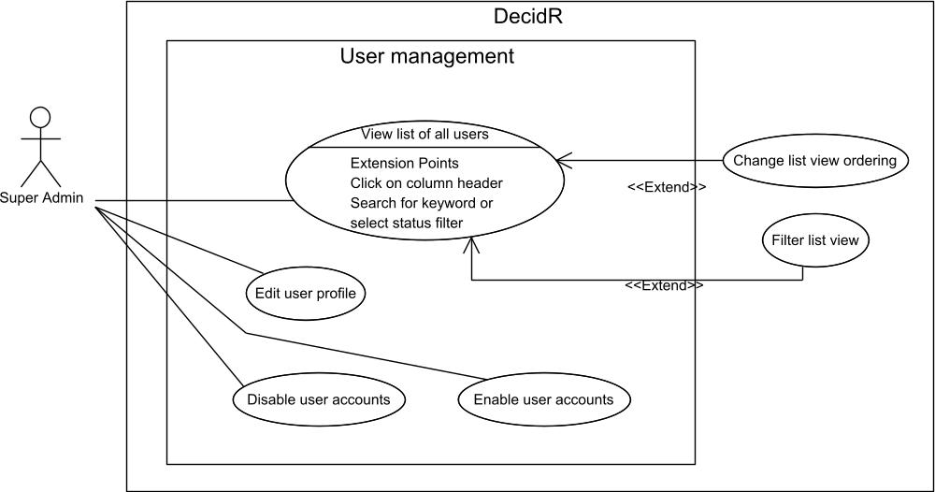

Figure 40: use case overview “user management”

View list of all users
Priority | Must-have
Reference | Figure 21: edit users (super admin)
Goal | The super admin wants to view a list of all users of the DecidR application, including registered as well as unregistered users.
Precondition | The super admin is logged in.
Basic flow | - The super admin navigates to the user list by selecting “Users” in the administration navigation menu.  - The system displays a list of all users in the web browser.
Postcondition | The super admin is logged in.  The web browser displays a list of registered and unregistered DecidR users.

Disable user accounts
Priority | Must-have
Reference | Figure 21: edit users (super admin)  View list of all users
Goal | The super admin wants to disable user accounts so the users won’t be able to use the DecidR application until their accounts are enabled.
Precondition | The super admin is logged in.  There is at least one registered or unregistered user in the system whose account hasn’t been disabled.
Basic flow | - The super admin navigates to the user list by selecting “Users” in the administration navigation menu.  - The system displays a list of all users in the web browser.  - The super admin selects a number of user accounts to disable.  - The super admin presses the disable button.  - The system checks whether any of the selected users are currently participating in a workflow. This is not the case.  - The system flags each selected user as disabled unless the user is the super admin himself.  - The system logs out each selected registered user except for the super admin himself.  - The system sends an info e-mail to each disabled user whose account was previously enabled.  - The system shows the updated user list in the web browser.
Postcondition | The super admin is logged in.  The system has disabled the selected user accounts.  The system has logged out all selected registered users.  The web browser displays the updated user list.  The system has sent an info e-mail to each disabled user whose account was previously enabled.
Alternative flow (1) | 5a. At least one selected user is participating in a workflow.  6a. The system displays a confirmation message in the web browser.  7a. The super admin confirms.  8a. Continue with step 6.
Alternative flow (1-1) | 7aa. The super admin declines.
Alternative postcondition (1-1) | The super admin is logged in.  The system has not disabled any of the selected user accounts.  The system has not logged out any of the selected registered users.  The web browser displays the updated user list.

Enable user accounts
Priority | Must-have
Reference | Figure 21: edit users (super admin)
Goal | The super admin wants to enable user accounts so the users will once again be able to use the DecidR application.
Precondition | The super admin is logged in.  There is at least one registered or unregistered user in the system whose account has been disabled.
Basic flow | - The super admin navigates to the user list by selecting “Users” in the administration navigation menu.  - The system displays a list of all users.  - The super admin selects a number of users to enable.  - The super admin presses the enable button.  - The system removes the disabled flag of each selected user account.  - The system sends an info e-mail to each enabled user whose account was previously disabled.  - The system displays the updated user list in the web browser.
Postcondition | The super admin is logged in.  The system has enabled the selected user accounts.  The enabled users are once again able to log in.  The web browser displays the updated user list.  The system has sent an info e-mail to each enabled user whose account was previously disabled.

Edit user profile
Priority | Desirable
Reference | Figure 8: profile page  7.12.1 View list of all users
Goal | The super admin wants to edit a user profile, possibly because it contains false or illegal information.
Precondition | The super admin is logged in.  There is at least one registered user.
Basic flow | - The super admin navigates to the user list by selecting “Users” in the administration navigation menu.  - The system displays a list of all users.  - The super admin selects the user whose profile should be edited.  - The system displays the current profile of the selected user in the web browser.  - The super admin enters the new profile data.  - The super admin presses the save button.  - The system successfully validates the new profile data.  - The system stores the new profile information.  - The system displays the updated profile of the selected user in the web browser.
Postcondition | The super admin is logged in.  There is at least one registered user.  The system has updated the selected user’s profile with the new data.
Alternative flow | 7a. The new profile data is invalid.  8a. The system displays an error message in the web browser. Continue with step 5.

Tenant Management
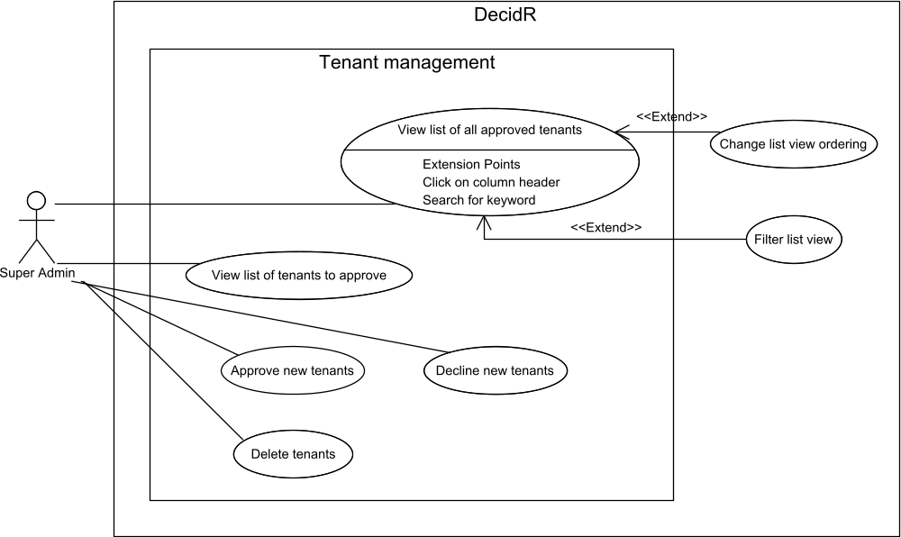

Figure 41: use case overview “tenant management”

View list of all approved tenants
Priority | Must-have
Reference | None.
Goal | The super admin wants to view a list of all approved tenants in the system.
Precondition | The super admin is logged in.
Basic flow | - The super admin navigates to the list of approved tenants by selecting “Approved tenants” in the administration navigation menu.  - The system displays a list of all approved tenants in the web browser.
Postcondition | The super admin is logged in.  The web browser displays the list of approved tenants.

Delete tenants
Priority | Must-have
Reference | Figure 18: edit tenants
Goal | The super admin wants to completely remove a tenant, including its workflow models and workflow instances.
Precondition | The super admin is logged in.  There is at least one approved tenant.
Basic flow | - The super admin navigates to the list of approved tenants by selecting “Approved tenants” in the administration navigation menu.  - The system displays a list of all approved tenants in the web browser.  - The super admin selects the tenants to remove.  - The super admin presses the delete button.  - The system displays a confirmation dialog in the web browser.  - The super admin confirms the deletion.  - The system terminates all running workflow instances of the selected tenants, and then removes the selected tenants and all workflow models and workflow instances of the selected tenants.  - The system sends an info e-mail to the tenant admin.  - The system displays the updated list of approved tenants in the web browser.
Postcondition | The super admin is logged in.  The system has removed the selected tenants and their workflow models and workflow instances.  The web browser displays the updated list of approved tenants.  The system has sent an info e-mail to the tenant admin.
Alternative flow (1) | 6a. The super admin cancels the deletion
Alternative postcondition (1) | The super admin is logged in.  The system hasn’t deleted the selected tenants.  The web browser displays the list of approved tenants.
Alternative flow (2) | 7a The super admin is trying to remove the default tenant, which cannot be removed.  8a. The system displays an error message in the web browser.
Alternative postcondition (2) | The super admin is logged in.  The system hasn’t deleted the selected tenants.  The web browser displays an error message.

View list of tenants to approve
Priority | Must-have
Reference | Figure 19: tenant approval
Goal | The super admin wants to view a list of all tenants that need manual approval.
Precondition | The super admin is logged in.
Basic flow | - The super admin navigates to the list of tenants that require approval by selecting “Tenants to approve” in the administration navigation menu.  - The system displays a list of all tenants that need approval and the user that is requesting to become tenant administrator in the web browser.
Postcondition | The super admin is logged in.  The web browser displays the list of tenants that need approval.

Approve new tenants
Priority | Must-have
Reference | Figure 19: tenant approval
Goal | The super admin wants to approve a new tenant so the tenant administrator may begin creating workflow models, changing the tenant settings, etc.
Precondition | The super admin is logged in.  There is at least one new tenant waiting for approval.
Basic flow | - The super admin navigates to the list of tenants that require approval by selecting “Tenants to approve” in the administration navigation menu.  - The system displays a list of all tenants that need approval in the web browser.  - The super admin selects a set of tenants to approve.  - The super admin presses the approve button.  - The system unlocks the selected tenants.  - The system sends an e-mail to each tenant admin telling them about the approval.  - The system displays the updated list of tenants that need approval in the web browser.
Postcondition | The super admin is logged in.  The system has unlocked the selected tenants.  The web browser displays the updated list of tenants that need approval.  The system has sent e-mails telling the tenant administrators about the approval.

Decline new tenants
Priority | Must-have
Reference | Figure 19: tenant approval
Goal | The super admin wants to decline a new tenant.
Precondition | The super admin is logged in.  There is at least one new tenant waiting for approval.
Basic flow | - The super admin navigates to the list of tenants that require approval by selecting “Tenants to approve” in the administration navigation menu.  - The system displays a list of all tenants that need approval in the web browser.  - The super admin selects a set of tenants to approve.  - The super admin presses the decline button.  - The system deletes the selected tenants.  - The system sends an e-mail to each tenant admin telling them about the refusal to approve the new tenant.  - The system displays the updated list of tenants that need approval in the web browser.
Postcondition | The super admin is logged in.  The system has deleted the selected tenants.  The web browser displays the updated list of tenants that need approval.  The system has sent e-mails telling the would-be tenant administrators about the decline.

System Maintenance
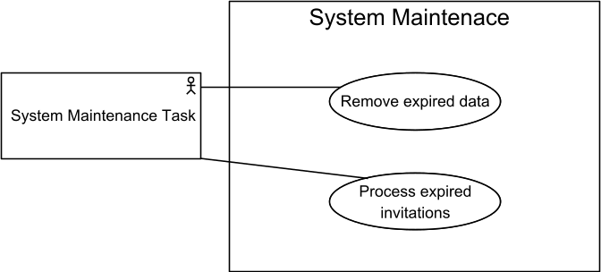

Figure 42: use case overview “System Maintenance”

Remove expired data
Priority | Must-have
Reference | None
Goal | The system maintenance task must remove all expired and useless data in the system, such as invitations that have expired several months ago.
Precondition | The system maintenance task is running.
Basic flow | - The system maintenance task connects to the database and removes all expired invitations.
Postcondition | The system maintenance task is running.  The system maintenance task has removed all expired and useless data from the database.  The system maintenance task hasn’t deleted any valuable data from the database.
Alternative flow | 1a. The system maintenance task cannot establish a connection with the database or the transaction fails.  2a. The system maintenance task sends an info e-mail to the super admin.
Alternative postcondition | The system maintenance task is running.  The system maintenance task has sent an info e-mail to the super admin.

Process expired invitations
Priority | Must-have
Reference | None
Goal | The system maintenance task must process invitations that have recently expired. There may be workflow instances which are still waiting for these invitations to be confirmed that must be terminated.
Precondition | The system maintenance task is running.
Basic flow | - The system maintenance task connects to the database.  - The system maintenance task looks up all expired invitations that it hasn’t already processed.  - For each found invitation, the system maintenance task terminates all workflow instances that were awaiting the invited user’s confirmation and flags the corresponding invitation as processed. The system maintenance task also sends an e-mail to the user that sent the invitation telling him that the invited user failed to accept or reject the invitation within the time limit.
Postcondition | The system maintenance task is running.  The system maintenance task has terminated the workflow instances that were awaiting the confirmation of an expired invitation.  The system maintenance task has sent info e-mails to the senders of the invitations.
Alternative flow | 1a. The system maintenance task cannot establish a connection with the database or the transaction fails.  2a. The system maintenance task sends an info e-mail to the super admin.
Alternative postcondition | The system maintenance task is running.  The system maintenance task has sent an info e-mail to the super admin.

Misc. Features
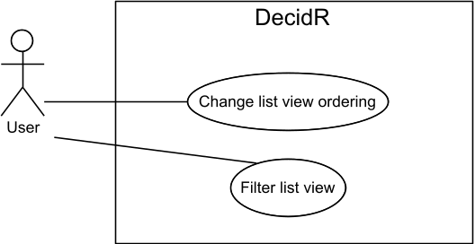

Figure 43: use case overview “Misc. features”

Change list view ordering
Priority | Must-have
Reference | Figure 17: edit user list (tenant admin)
Goal | The user wants to change the ordering of the list view by a certain column. Available columns depend on the kind of list view that is displayed.
Precondition | The web browser displays a list view of some sort, such as the tenant member list in the user administration. It is currently sorted by some column in ascending or descending order. The user may have applied filters to the list view.
Basic flow | - The user clicks on the header of a column that isn’t currently used to sort the list view.  - The system displays the updated list view, now sorted by the selected column in ascending order.
Postcondition | The web browser displays the updated list view, now sorted by the selected column in ascending order. If the user had previously applied filters to the list view, they still apply.
Alternative flow | 1a. The user clicks on the header of the column that is currently used to sort the list view.  2a. The system displays the updated list view, now sorted by the selected column in the reversed order.
Alternative postcondition | The web browser displays the updated list view, now sorted by the selected column in the reversed order.  If the user had previously applied filters to the list view, they still apply.

Filter list view
Priority | Must-have
Reference | Figure 17: edit user list (tenant admin)
Goal | The user wants to filter a list view by keyword or other filters. Available filters depend on the kind of list view that is displayed.
Precondition | The web browser displays a list view of some sort, such as the tenant member list in the user administration. It is currently sorted by some column in ascending or descending order. The user may already have applied some filters to the list view.
Basic flow | - The user selects a set of filters to apply to the list view from the filters area.  - The user presses the filter button.  - The system updates the list view using the selected filters.
Postcondition | The web browser displays the updated list view, which is still sorted by the same column in the previous order. The system has applied the new set of filters to the list view.

Nonfunctional Requirements

Quantity Structure

User
In the system exactly one super admin exists. The number of users per tenant is not limited. The number of workflow admins per tenant is not limited, i.e. every user may administer every workflow model in the most extreme case.

User Roles
There are no limits to how many tenants a user can administrate, in how many workflows he can take part and in how many workflows he can administrate.

Workflow models / instances
The system is expected to comply with the performance requirements for up to 1000 workflow models and up to 1000 running workflows per tenant at the same time. Each workflow instance is administrated by one or more workflow administrators.

File Size
- E-Mail attachments and human task activity uploads are limited to 10 MB per file.
- The maximum tenant logo file size is 100 KB after being resized by the system.

Registration
For each e-mail address only one account can exist. One account is associated with exactly one e-mail address.

Tenants
There is no limit to the number of tenants which can exist. Each tenant is administered by exactly one registered user.

Time Limits
- Users must follow registration links within 72 hours or else the invitation becomes invalid.
- Users must confirm their e-mail address within 72 hours. If they do not, the e-mail change request becomes invalid.
- Users are automatically logged out if they do not interact with the web site for one hour.

User Input Constraints
Field(s) | Constraints
Tenant description text | Up to 5000 UTF-8 characters.
Tenant name | At least one word consisting of at least 2 and up to 50 alphanumerical UTF-8 characters, with at most one space character between two words. The overall maximum tenant name length is 50 UTF-8 characters.
Tenant logo | The user may upload GIF, JPEG and PNG files.
Invitations | Up to 50 user names or e-mail addresses.
User profile data | - First name (optional, up to 50 UTF-8 characters)  - Last name (optional, up to 50 UTF-8 characters)  - Street (optional, up to 100 UTF-8 characters)  - Postal code (optional, up to 15 UTF-8 characters)  - City (optional, up to 50 UTF-8 characters)  - User name (mandatory, at least 3 UTF-8 characters, up to 20 UTF-8 characters)  - E-mail address (mandatory, valid e-mail address)  - Password (mandatory, see Password Policy)
Workflow model name | Up to 50 UTF-8 characters. Workflow model names do not have to be unique within the owning tenant or even the entire system.

Workflow Instance Statuses
Status | Meaning
Awaiting confirmation | The workflow instance is not yet running, but will be started once all users have confirmed their invitations. If at least one user rejects his invitation, the workflow instance will be terminated.
Running | The workflow instance is being executed by the BPEL engine.
Terminated | The workflow instance was halted due to an error and couldn’t successfully complete. It is no longer being executed by the BPEL engine.
Completed | The workflow instance has reached its end activity without errors. It is no longer being executed by the BPEL engine.

Work Item Statuses
Status | Meaning
New | The user has not started working on the work item yet. The user may work on work items that are new.
In progress | The user has started working on the work item, but hasn’t finished his work yet. The user may work on work items that are in progress.
Done | The user has finished working on the work item. The user may not work on work items that are done.

Performance Requirements & Scalability
DecidR does not need to fulfill any kind of higher-than-average performance requirements. A key performance indicator is the time between navigating to a web page on the front-end and the moment when the web browser finishes loading that web page and displays its content. This time span should not exceed five seconds.
The system must be designed to scale well, so the performance requirements can be met even with thousands of users using the system concurrently. Scaling the system should be as easy as starting another server instance and updating a few configuration files. Under no circumstance should adding new server instances require changes in source code files.

Safety Requirements
There are no requirements concerning possible loss, damage, or harm that could result from the use of DecidR. In case of data loss, the operator of the DecidR application is not obliged to compensate the tenants for any resulting damage. The safety of the data depends on the used storage systems and services.

Security Requirements
All Web services and server components of the DecidR application must be designed to be resilient to attacks. Mechanisms for strong input validation and encrypted communication must therefore be considered during the design phase. Connections to the database must be secured using SSL and X509 certificates with client and server validation.

Password Policy
Users who are registering at the DecidR web site are required to choose a password consisting of at least eight UTF-8 characters. The password must contain at least one non-alphanumeric character. After ten consecutive unsuccessful login attempts, the super admin is informed of the potential brute force attack via e-mail.

Privacy Protection
Since many users use the same password on many sites, DecidR must use an authentication method that does not reveal the password even if an attacker gains access to the database. Connections to the web front-end must be secured using SSL.

Logging
The customer wants as much logging as possible, i.e. it must be possible to record every action that takes place within the system. In particular, starting a new workflow instance and invocation of a Web service must be logged extensively. The super admin can adjust the log level via the system settings.

Software Quality Attributes

Usability
High usability is a very important requirement. The web-based front-end should provide an intuitive and easily usable interface. Even users with little technical experience must be able to interact with the system. There are no requirements concerning accessibility features for blind or handicapped persons.

Extensibility and Changeability
It is almost certain that development of the DecidR application will continue in a future project with a completely different team. Typical extensions would include internationalization, creating new Web services, or adding new elements to the modeling tool. Components that are subject to change include the storage backend and the web site layout.
DecidR must therefore be designed so that changes as well as extensions can be carried out with reasonable effort. Loose coupling and thorough documentation are the two main pillars that make extensions and changes to DecidR possible.

Expected Extensions
Billing: in the future it must be possible that a tenant admin can charge money for using his published workflow models. The software architecture must allow easy extensibility in this matter.
DecidR Workflow Definition Language: transition conditions and BPEL snippets (i.e. arbitrary BPEL code) will be added at some point in the future.
Workflow modeling tool: each extension to the workflow modeling language requires changes to the modeling tool in order to represent the new elements graphically.

Availability
Failures of a particular Web service should not cause the front-end and features that do not depend on that Web service to fail as well. Furthermore, launching additional server instances should increase the availability of the application by making use of the failover options provided by the Synapse ESB.
The project team cannot take responsibility for server outages on the side of the Amazon EC2 or due to bugs in MySQL, Tomcat, Axis2, ODE or Synapse.

Testability
Each developed Web service must come with a JUnit / SoapUI test suite for automated unit testing. While it is difficult to provide this for the servlets that make the web front-end, automated tests will be delivered where no user interaction is required to produce meaningful input data. The same goes for the JavaScript-based workflow modeling tool.

Portability
Since the DecidR application is entirely based on Java™ there are no special portability requirements. The application is expected to be deployable in any environment where Tomcat 5.5.x and Synapse 1.2 are executable. The system must be designed to allow exchanging the underlying persistent data storage within a few working days. To achieve this, the JPA is used as a database abstraction layer.

Robustness
The system must react in a robust way to invalid user input. This means that the system should react to invalid user input by generating meaningful error messages and should not simply crash. Strong input validation is therefore required in all subsystems.

Business Rules
This section summarizes the conditions under which the use cases may be executed.

Code | Meaning
● | Always – i.e. no additional condition
E | The user account hasn’t been disabled by the super admin.
L | The user is logged in (implies E).
NL | The user is logged out.
NNT | Name or e-mail address not yet taken
NWF | Not participating in a workflow
TL | Time limit
I | The user has received the necessary invitation.
(empty) | The user may not execute this use case or the use case does not apply to the actor.

Use Case | Super Admin | Tenant Admin | Workflow Admin | Registered User | Unreg. User
Info Pages
View “Impressum" | ● | ● | ● | ● | ●
View terms of service | ● | ● | ● | ● | ●
View help | ● | ● | ● | ● | ●
View welcome page | ● | ● | ● | ● | ●
Account Management
Register account as tenant-admin | NNT + NL | NNT + NL | NNT + NL | NNT + NL | NNT
Register account as normal user | NNT + NL | NNT + NL | NNT + NL | NNT | NNT
Confirm registration | E + NL | E + NL | E + NL | E + NL | E
Log into account from default welcome page | E + NL | E + NL | E + NL | E + NL | E
Log into account from tenant welcome page | E + NL | E + NL | E + NL | E + NL
Change forgotten account password | E + NL | E + NL | E + NL | E + NL
Confirm tenant membership invitation | E + I | E + I | E + I | E + I | E + I
Confirm workflow administration invitation | E + I | E + I | E + I | E + I | E + I
Change e-mail address | L | L | L | L
Change password | L | L | L | L
Change address data | L | L | L | L
Cancel membership |  |  | L + NWF | L + NWF
Log out of account | L | L | L | L
Create tenant | L | L | L | L
Switch Tenant | L | L | L | L
Set user status to available | L | L | L | L
Set user status to unavailable | L + NWF | L + NWF | L + NWF | L + NWF
Leave Tenant |  |  | L + NWF | L + NWF
Workflow participation
Display work items from current tenant | L | L | L | L | I
Display work items from all tenants | L | L | L | L | I
Start working on a work item | L | L | L | L | I
Resume working on a work item | L | L | L | L | I
Mark work item as done | L | L | L | L | I
Workflow instance management
View workflow models | L | L | L
View own workflow instances | L | L | L
Prepare workflow instance configuration | L | L | L
Create workflow instance | L | L | L
Start workflow instance (from a prepared workflow instance configuration) | L | L | L
Change user roles of a prepared workflow instance configuration | L | L | L
Add user to a prepared workflow instance configuration | L | L | L
Remove user from a prepared workflow instance configuration | L | L | L
Complete work item for a user | L | L | L
Terminate workflow instance | L | L | L
Tenant settings
Change tenant settings | L | L
Change tenant logo | L | L
Upload custom CSS | L | L
Define simple color scheme | L | L
Restore default tenant settings | L | L
Tenant user management
Invite users to tenant | L | L
Remove users from tenant | L | L
View tenant members | L | L | L
Transfer tenant admin role to another user | L | L
View other user’s profile | L | L
Workflow modeling
Create new workflow model | L | L
Delete workflow models | L | L
Lock workflow models | L | L
Unlock workflow models | L | L
Import published workflow model | L | L
Publish workflow models | L | L
Un-publish workflow models | L | L
View list of tenant workflow models | L | L
View list of published workflow models | L | L
Appoint workflow admins | L | L
Appoint oneself as workflow admin | L | L
Appoint registered users as workflow admins | L | L
Appoint unregistered users as workflow admins | L | L
Workflow model editor
Open existing workflow model for editing | L | L
Save workflow model | L | L
Clear workflow model | L | L
Insert new activity | L | L
Insert new container | L | L
Edit activity | L | L
Edit container | L | L
Delete activity | L | L
Delete container | L | L
Add variable | L | L
Edit variable | L | L
Delete variable | L | L
Connect activities or containers | L | L
Undo last action | L | L
Redo last action | L | L
Tenant monitoring
View tenant status | L
System settings
Edit system settings | L
System status
View list of all workflow models | L
View list of all running workflow instances | L
User Management
View list of all users | L
Disable user accounts | L
Enable user accounts | L
Edit user profile | L
Tenant Management
View list of all approved tenants | L
Delete tenants | L
View list of tenants to approve | L
Approve new tenants | L
Decline new tenants | L
Misc Features
Change list view ordering | ● | ● | ● | ● | ●
Filter list view | ● | ● | ● | ● | ●

Applicable Technologies
The following table lists the version numbers of software and standards that are used by the DecidR application:

Component | Version
Apache ODE BPEL Engine | 1.2
Apache Synapse ESB | 1.2
Tomcat Servlet Container | 5.5.x
Axis2 Web service Engine | 1.4.2
MySQL DBMS | 5.1.30
JavaServer Pages | 2.0
Servlets | 2.4
Java Runtime Environment | 1.6
Web services Business Process Execution Language (WS-BPEL) | 2.0
Web services Description Language (WSDL) | 1.1

